

**A new word of grocery shopping**

**-: Project Developed By :-**

Pambhar Menish Dilipbhai

Pambhar Harita Dilipbhai

**-: Project Guided By :-**

Vidhi Mam

**-: Front End Tool :-**

Visual studio 2022

**-: Back End Tool :-**

Microsoft SQL Server Management

**-: Submitted To :-**

Saraswati College of Commerce BBA & IT, Dhoraji.

**-: INDEX :-**

|  |  |  |
| --- | --- | --- |
| **SR. NO.** | **SUBJECT** | **PAGE NO.** |
| **1** | Preface |  |
| **2** | Acknowledgement |  |
| **3** | Manual System |  |
| **4** | Proposed System |  |
| **5** | System Analysis & Design |  |
| **6** | Data Flow Diagram |  |
| **7** | Feasibility Study |  |
| **8** | Testing Methods |  |
| **9** | Requirements (Software & Hardware) |  |
| **10** | About C#.NET |  |
| **11** | About SQL Server |  |
| **12** | Client Server Application |  |
| **13** | Table Structure |  |
| **14** | Relationship Between Tables |  |
| **15** | Screenshot |  |
| **16** | Reports |  |
| **17** | References |  |
| **18** | Bibliography |  |

PREFACE

* “ JioMart Grocery Store Management ” was taken by us in our third year in project Work for the partial fulfillment of BCA (5) at Saraswati College – Dhoraji.
* It is matter of also pleasure for us submitting this documentation Of the project work done during the third year BCA.
* The purpose of this project is to learn and implement the concept System development. any solution is the result of integration of the theory as well as Practical.
* Here is the detailed report on the project “ JioMart Grocery Store management ”.
* Computer is an inherit part of the life today. Virtually, In every walk of life, a person in expected to be able to use computers.
* It was developed on Microsoft SQL Server Management as “back-end” tool and C# 2022 As “Front-end” tool with using connection.

ACNOWLEDGEMENT

* Over sincere “THANKS” goes to :
* We are very thankful to MR. KATHIRIYA DILIP , Properties of “SARASWATI COLLEGE MANAGEMENT - DHORAJI”. Who gave us the golden opportunity to undertake this project and provide necessary information related to our project.
* We are heartily thankful to the principal and head of computer science department in our COLLEGE for all the efforts and interest they have taken for the realization of our project.
* We are gratefully thinks to our M/s VIDHIMAM for supporting us and through entire project and special thanks to our entire staff of IT department and our friends who always stood with us and had been to the constant support.
* We are also thankful the qualified staff of the college and especially our lab faculty member for leading & guiding us to perform our Activities very well.
* Once again we thank all who helped us directly or indirectly during our project.

MANUAL SYSTEM

* Our project software project for "JIOMART GROCERY STORE MANAGEMENT”.
* We are maintains system and firstly we are discussing how the system works. The manual system maintained works as a manual like write down all student details, staff details and college information.
* Before some time ago the system was done manually then the process was time consuming and also it way create some mistake for the calculation.
* Thus, we may find many and great problems with manual system which feels the beach resort to, serve to the best of their on ability and on efficiency.
* There are manually more than many disadvantages of the current system are as follows.
* **DISADVANTAGES OF CURRENT SYSTEM AND MANUAL SYSTEM :-**
* Time consuming
* Labor-intensive
* Entries of repeated
* Decision making
* Business continuity

PROPOSED SYSTEM

* System in proposed system is computer based work.
* Here, we are using a computer for handling the routing activities like maintaining detail of all student information and staff details. As your as proposed system is concemed, there is no requirement of registers, receipt, transaction book etc..
* The addition, deletion and modification can be done easily through Proposed system. compare with manual system proposed system makes calculation easy and fastest.
* Proposed system has a good user interface and it's totally User Oriented So use, we take a lot of care durmg the development of system.
* There are many advantages of the proposed system are as follows:
* **ADVANTAGES OF PROPOSED SYSTEM :-**
* Increasing business profitability
* Reducing business cost
* Better internal control
* Increasing market competitiveness
* Economy in storage space and material

SYSTEM ANALYSIS & DESIGN

* **SYSTEM ANALYSIS FOR DEFINITION :-**
* System analysis is a problem solving technique that decomposes a system into its component pieces for the purpose of the studying how well those component parts work and interact to accomplish their purpose. According to the Merriam-Webster dictionary system analysis is "the process of studying a procedure or business in order to identify its goals and purpose and create systems and procedures that will achieve them an efficiently". Analysis and synthesis, in Scientific methods, always go hand; they complement one another every synthesis is built upon the results of a preceding analysis, and every analysis requires a subsequent synthesis in order to verify and correct its results: as
* **SDLC DIAGRAM (SYSTEM DEVELOPMENT LIFE CYCLE) :-**

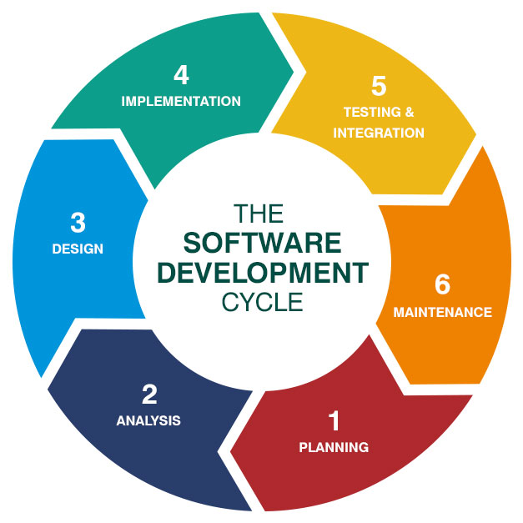

* **SDLC :- Software Development Life Cycle.**

**SAD** :- software analysis designer.

* **STEP FOR SDLC :-**
* Preliminary investigation:-
* Determination of system requirement:-
* Design of system:-
* Development of software:-
* Systems testing:-
* Implementations, evaluation & maintenance:-

**[1] Preliminary investigation :-**

* Preliminary investigation for software development team and organization to find out on information and study how to develop software.
* Preliminary investigation two check feasibility study.

[A] Technical feasibility

[B] Time feasibility

**[2] Determination of system requirement :-**

* In this phase is a system in requirement document.
* Any organization can be on decided same.

[A] How is it being done?

* In this of requirements of question in it is only one by one requirement's SAGEMENT SYSTEM

[B] Design of system :-

* In this phase to develops in design of the system. In this phase algorithm on flow-chart many clearly date in pad.
* Designer select on and stored devices of storage devices.

[C] Development of Software :-

* In this phase is a software on develop with properness documentation. Developer (programmer) can write program using current languages or technology

[5] Systems Testing :-

* In phase to check system is a wart ting on node. There are different are level in method.
* White box, black box, big bang, etc.....

[6] Implementations, evaluation & maintenance :-

* Implementation is the process of starting work with new software new equipment of the system is the Perform training figure and strength and weakness.
* **Maintenance:**
* There are four type of an maintenance
* Corrective
* Adaptive
* Perfective
* Preventive
* We cannot give grantee of 100% error free software.

DATA FLOW DIAGRAM

* **CONTEXT LEVEL DIAGRAM :-**

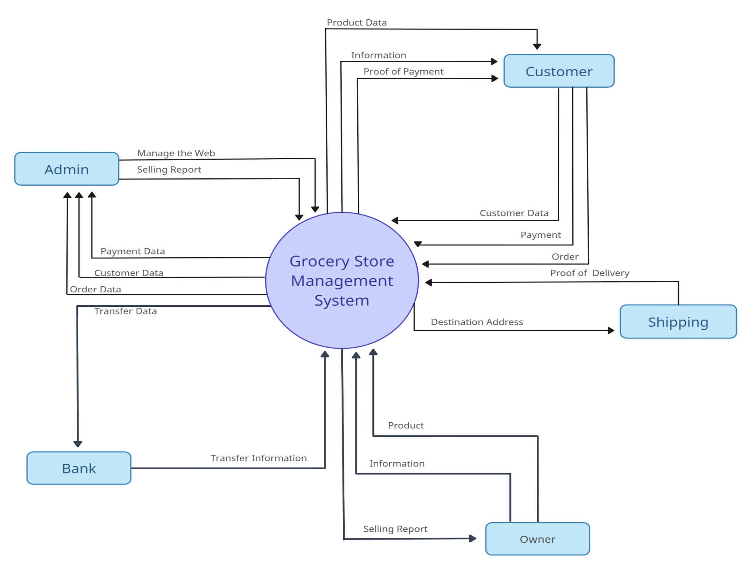

* **ER-DIAGRAM GROCERY STORE MANAGEMENT :-**

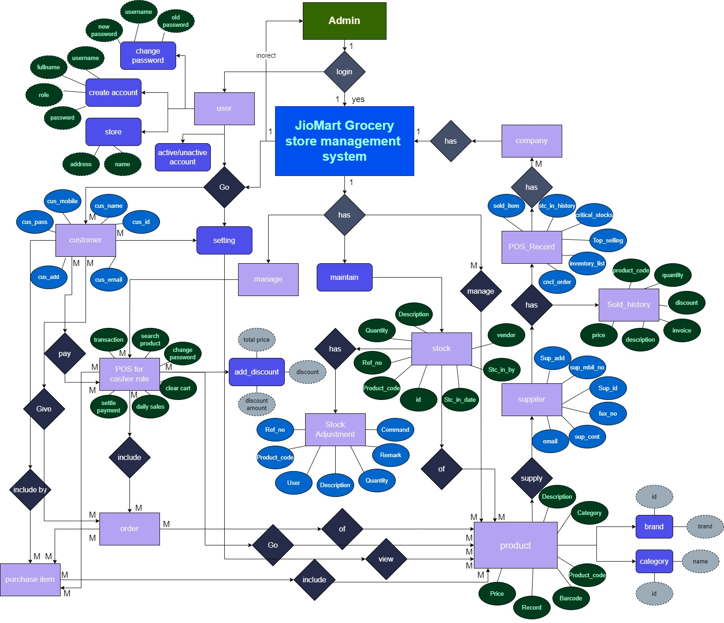

Feasibility Study

* The main aim of feasibility study is to determine whether developing. The product of our project is financially and technically feasible.
* The feasibility study involves the analysis of the problem and collection of the problem and collection of data required to be carried out on these data, the output data required to be product by the system, as well study of various constraint on the behavior of the system.
* There are three major areas that determine feasibility of the project.
* These all combine defines whether the project is feasibility or not.
* Technical Feasibility
* Operational Feasibility
* Economical Feasibility

**(1) TECHNICAL FEASIBILITY :-**

* Technical feasibility is considered in terms of technical are in the market it determines on whether the current level of on technology supports the proposed system or not. The technical feasibility are on possibility of proposal system is as follows.
* This unit does process the hardware as well as related software for the project. The proposed system does not require much technical detail. It just requires windows operating system.
* These technical specifications are easily available in the market.
* **Question :**
* 0 Your purpose system which are needed like printer?

**Ans :**  Yes

**2) OPERATIONAL FEASIBILITY :-**

* The proposed system will fulfill the organization's requirements.
* The changes of the system being operational are quite strong.
* It is a used by unite natural that the organizations are ready to go ahead and work with proposed system.
* **Question :-**

1. Do you have a enough resources to operable proposed System?

**Ans** : Yes, this system the operable proposed system.

**3) ECONOMICAL FEASIBILITY :-**

* The economical feasibility of the proposed system.
* The organizations are ready to invest in proposed system for latest technology and best result. The unit has not to spend much amount for the computers are hardware and software.
* As a result the project processes the economical feasibility.
* **Question :-**

1. This system having the suitable budget in purpose system?

**Ans :** They give as limited budget is 5000.

TESTING METHODS

* Testing was done on the regular base during the coding phase itself. Some error that remains uncovered that is done properly at the time of testing.
* There are different methods which can be use of software testing. This chapter briefly described those methods:

1. ⚫BLACK BOX TESTING
2. WHITE BOX TESTING

* **BLACK BOX TESTING :-**
* The techniques of testing without having of any knowledge of the interior working of application is black box testing Black box testing to finding error a give below:

1. Incorrect or missing function
2. Interface e ASWATI COLLEGE
3. Performance error

* The tester is oblivious to the system architecture and does not have access to the source code.
* Typically, when performing a black box test, a tester will interact with providing inputs and examining outputs.
* In Mack box testing approach, test cases are designed using only the functional specification of the software product. The black box testing is also referred to as functional testing.
* The functional testing approach for this techniques is as shown below:
* Equivalence partitioning
* Boundary value analysis.
* Decision table
* State transition table.
* **ADVANTAGES OF BLACK BOX TESTING :-**
* Well suited and efficient for large code segments.
* Code access not required.
* **DISADVANTAGES OF BLACKBOX TESTING :-**
* Limited average since only selected number of test scenarios are actually performed.
* Blind coverage, since the tester can’t target specific code or error areas.

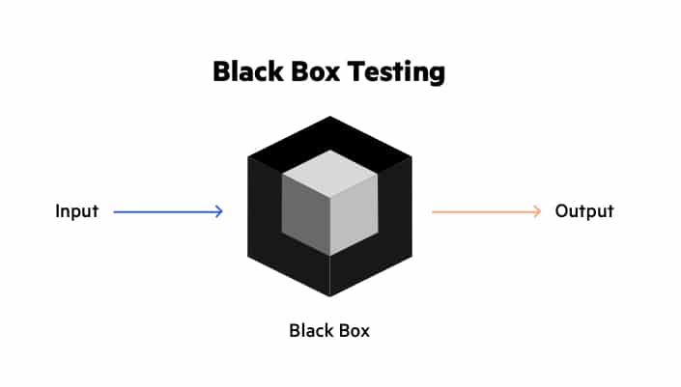

* **WHITE BOX TESTING :-**
* White box testing is the detailed investigation of internal logic and structure of the code. White box testing is also called glass testing or open box testing.
* In order to perform white box testing on an application, the tester needs to process knowledge for the internal working of the code. The tester needs to have a look inside the source code and find out which unit of the code is behaving in them.
* **White box testing there are two methods :**
* Statement testing and coverage
* Decision testing and coverage
* **ADVANTAGE OF WHITE BOX TESTING :**
* It helps in optimizing the code:
* Extra lines of code can be removed which can bring in hidden defects.
* Due to the tester's knowledgement about the code.

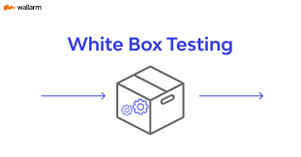

* **GREY BOX TESTING :-**
* Grey Box testing is a technique to test the application with having a limited knowledge of the internal workings of an application.
* In software testing, the phrase the more you know, the better carries a lot of weight while testing an application.
* Mastering the domain of a system always gives the tester an edge over someone with limited domain knowledge.
* Unlike black-box testing, where the tester only tests the application's user interface; in grey-box testing, the tester has access to design documents and the database.
* Having this knowledge, a tester can prepare better test data and test scenarios while making a test plan.

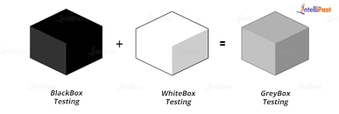

* **AUTOMATED TESTING :-**

1. **GUI testing :**

* ⚫GUI Testing is the process of ensuring proper functionality of the Graphical User Interface (GUI) for a given application and making sure it conforms to its written specifications.
* GUI Testing evaluates design elements such as layout, colors, fonts, fonts sizes, labels, text boxes, buttons, labels. GUI testing processes can be either manual or automatic, and are often performed by third party rather than developers or end users.
* ⚫ GUI Testing can require a lot of programming and is time consuming.

1. **Usability :**

* In Usability Testing basically the testers test the case with which the user interfaces can be used. It test that whether the application or the product built is user-friendly or not.
* Usability Testing is a black box testing technique is done with user point of view.
* Usability Testing also reveals whether users feel comfortable with your application according to different parameters-the flow navigation and layout, speed and content-especially in comparison to prior or similiar applications.

1. **Integration testing :**

* Integration Testing is the phase in software testing in which individual software modules are combined and tested as a group. It occurs after Unit Testing and before Validation Testing.
* At the time of module development there are wide chances of change in requirements by the client these new may not be unit tested and hence system testing becomes necessary interfaces of the software modules with the database could be erroneous.

1. **Unit testing :**

* Unit Testing is a software development process in which the smallest testable parts of an application, called units and are individually and independently tested for proper operation. Unit Testing can be done manually but is often automated.
* Unit Testing is the first level of testing and is performed prior to integration testing.
* Unit Testing are basically written and executed by the software developers to make sure that code meets its design and requirements and behaves as expected.
* Unit Testing is basically done before integration testing as show in the image box execute the unit test.

REQUIRMENTS (SOFTWARE & HARDWARE)

* **HARDWARE REQUREMENT :-**

|  |  |
| --- | --- |
| **HARDWARE COMPONENT** | **PRICE** |
| **Pentium Processor of Higher** | **Rs. 6050** |
| **RAM-4 GB or Higher** | **Rs. 2000** |
| **Hard Disk-250 GB or Higher** | **Rs. 3750** |
| **DVD Drive** | **Rs. 2500** |
| **Monitor and Other IO Devices** | **Rs. 46500** |

* **HARDWARE REQUREMENT :-**

|  |  |
| --- | --- |
| **SOFTWARE COMPONANT** | **PRICE** |
| **Microsoft Visual Studio 2022** | **Rs. 5450** |
| **Microsoft Sql Server Management** | **Rs. 4000** |
| **Windows 11 or Higher** | **Rs. 15500** |

* The prices of the related requirements described here are approximate.

ABOUT C#.NET

* **Introduction :-**
* Syntax is independently suited for the producing. Windows application MSWORD, MSACCESS for application and syntax in Microsoft C#.NET.
* Microsoft C#.NET content the tradition of simple powerful and easy to learn the programming language yet adds enough extended capabilities to satisfy the most jaded developer.
* **Future :-**
* First is MICROSOFT CONET huge product Millions of developers of all skills levels are producing application with.
* Second is MICROSOFT CNET is powerful development system. It contains built-in-functions and subroutines for dozens of different common tasks in the addition to tits intrinsic features MICROSOFT C.NET provides the capability to produce custom libraries and objects that can be loaded at time or bound the distributable application.
* Thirdly MICROSOFT CNET is also well supported by third party products. Just like oracle.
* Finally MICROSOFT CNET is a Microsoft product and Microsoft is indisputably the largest software company in the world.
* For all these and many more is indisputably the most attractive development environment currently available.
* In contract to the absolute system of the past MICROSOFT C#.NET has an undesirable bright and shining future.
* **APTLICATIONS :-**
* To create a application, you will need to learn to take small components and "glue them together into a complete application. The most common components you will use are forms, controls, classes, and Functions.
* **FORMS :-**
* Forms are windows up on which you built your user interface. Form is the base of Window Application in C#.Net.
* **CONTROLS :-**
* Controls are building block of user interface. Controls, also called Active X Controls, and button, that you use to display information to the user, gather information from the user, and respond to the user actions.
* **CLASSES :-**
* Classes are templates from which you can create your own object to run time. This reusable class modules aid you in organization your application into small components that can be built into a complete application.
* **FUNCTIONS :-**
* Functions are small routine you write that are callable from anywhere in your application into small components that can be called many times. COLLEGE.
* **EVENTS :-**
* Avery important in any windows programming language is Events An Event is something that occurs response in to a user interaction.

ABOUT /SQL SERVER

* Microsoft SQL Server 2005 extends the performance, reliability, qualified And case-to-use of Microsoft SQL Server version 7.0 Microsoft SQL Server 2005 includes several new features that make it an excellent database platform for large-scale transaction processing (OLTP), data warehousing, and e-commerce applications.
* The OLAP services feature available in SQL server version 7.0 is now called SQL server 2005 analysis Service the term AP Service has been replaced with the term Analysis Services. Analysis Services also includes a new data mining.
* The Repository component available in SQL Server version 7.0 is now called Microsoft SQL server 2005 beta Data Services. The term rapacity is used only in reference to the repository engine within mete data services.
* **EDITIONS OF THE MY SOL SERVER 2005 :-**
* The SQL server 2005 family uses the six editions....
* Mobile
* Workgroup
* Standard
* Enterprise
* Developer
* Each of these editions comes with a range of features. These include High Availability, Scalability to high business Intelligence tools.

CLIENT SERVER APPLICATION

* The application which is connected to any kind of server that this application divided into two parts like:
* Client
* Server
* **CLIENT :-**
* The client side approach is work as all data collecting activities for that project.
* Client is connecting to the server to handling all its internal. information for that project to work properly and reliably.
* Client side application is not required the server in other word we can say that the client side application depending on the client manager or user which currently use them but when the client have some importance data to be stored and used again when required, so user is used the server handling upon its data.
* This kind of part is responsible for the client and also managed by the client during the application.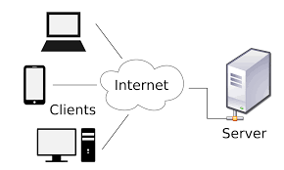
* **SERVER :-**
* The server side approach is work as all data storing activities into the database for managing the information of current project.
* The database server is connected to the client and provides all the result when the user fetches the data from the server and database of that project.
* Server side application has not required the user to manage it and its data.
* This kind of part is responsible for the database server and also managed by the database server during the application.

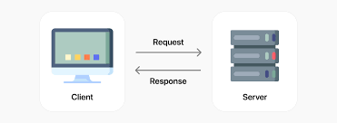

RELATIONSHIP BETWEEN TABLES

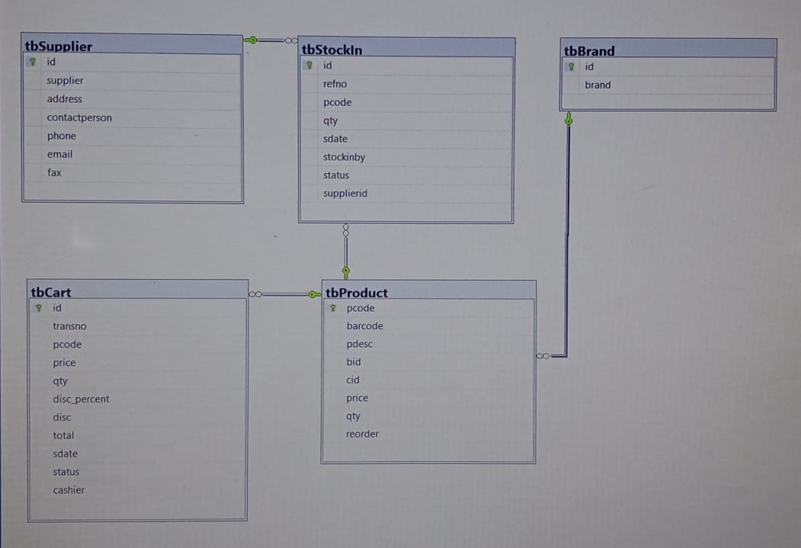

TABLE STRUCTURE

**Table :- 1**

**Table name :-** User

**Description :-** To signup & login into our project

**Application Primary Key :-** username

**Foreign Key :-**

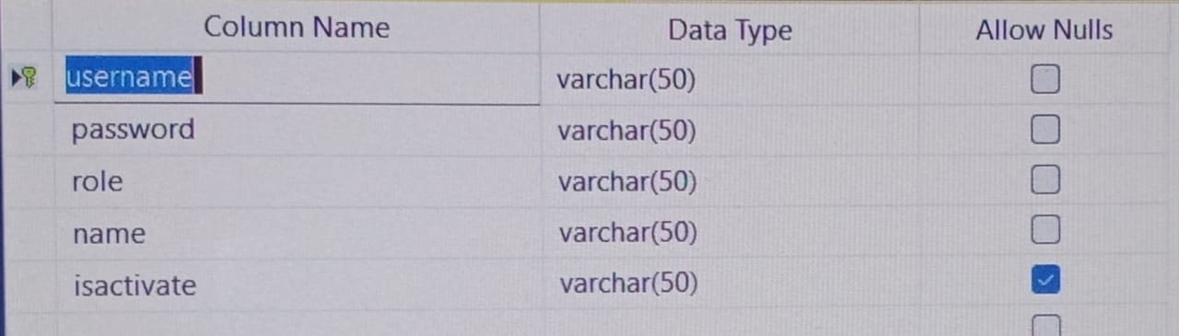

**Table :- 2**

**Table name :-** Supplier

**Description :-** To Store the Supplier information

**Application Primary Key :-** sup_id

**Foreign Key :-**

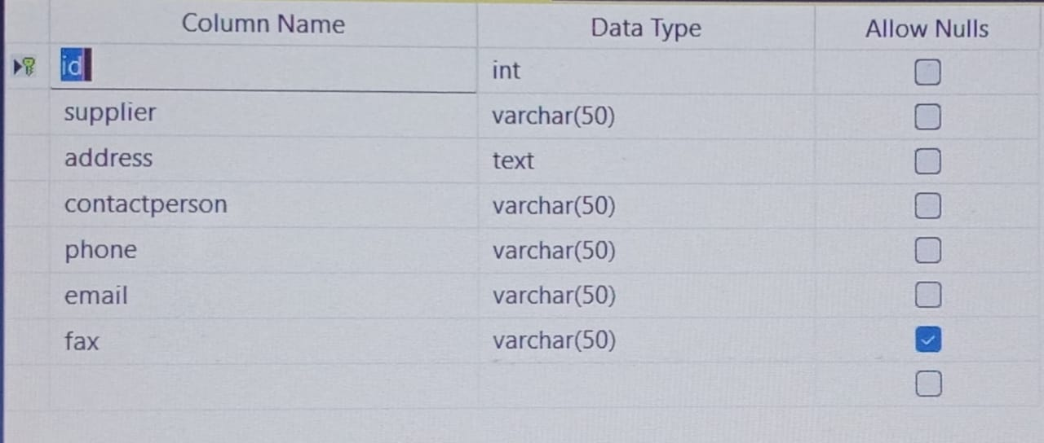

**Table :- 3**

**Table name :-** stock

**Description :-** To store the stock information

**Application Primary Key :-** stc_id

**Foreign Key :-**

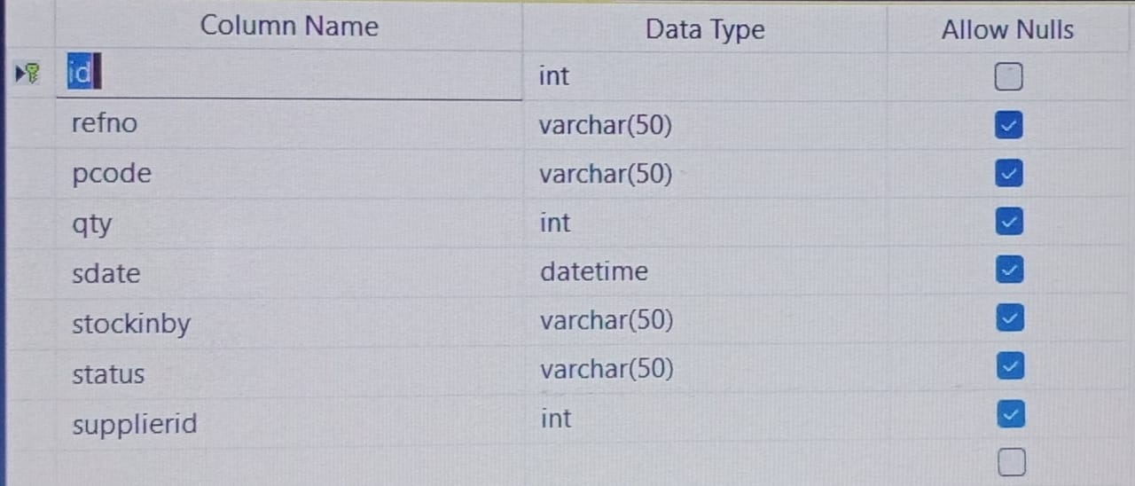

**Table :- 4**

**Table name :-** Cart

**Description :-** Indicate purchase item information

**Application Primary Key :-** cart_id

**Foreign Key :-**

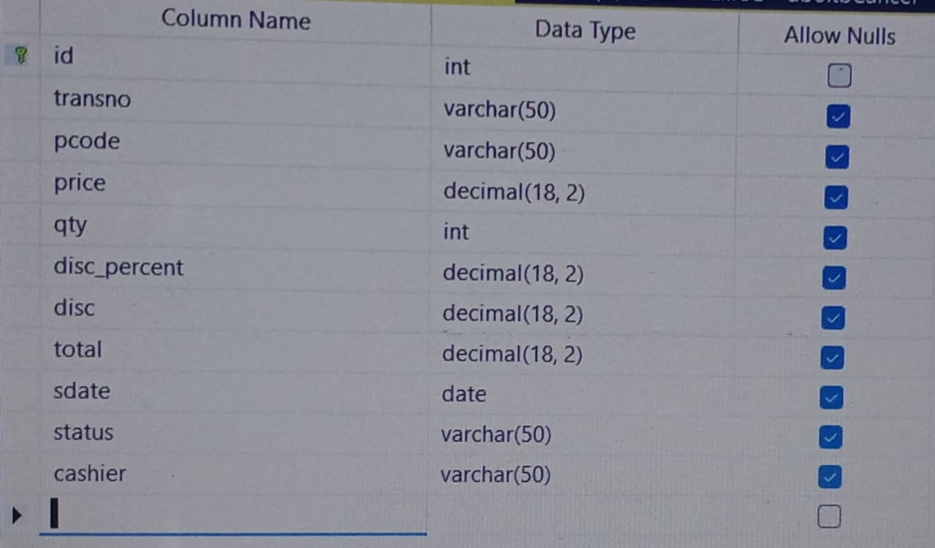

**Table :- 5**

**Table name :-** Category

**Description :-** To Store the category information

**Application Primary Key :-** cat_id

**Foreign Key :-**

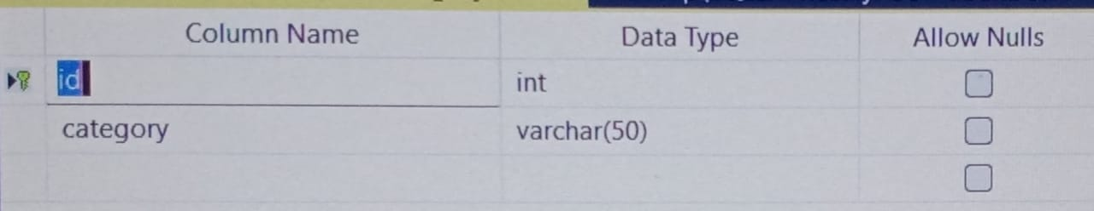

**Table :- 6**

**Table name :-** Store

**Description :-** To Input store information

**Application Primary Key :-** str_id

**Foreign Key :-**

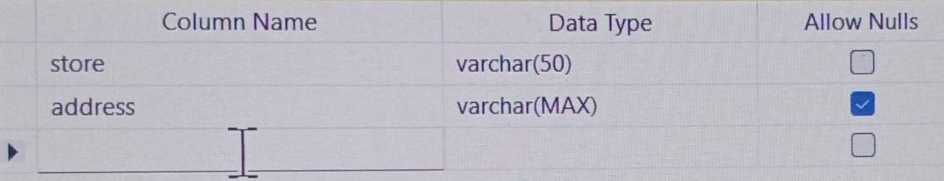

**Table :- 7**

**Table name :-** Product

**Description :-** To Store product information

**Application Primary Key :-** pcode

**Foreign Key :-**

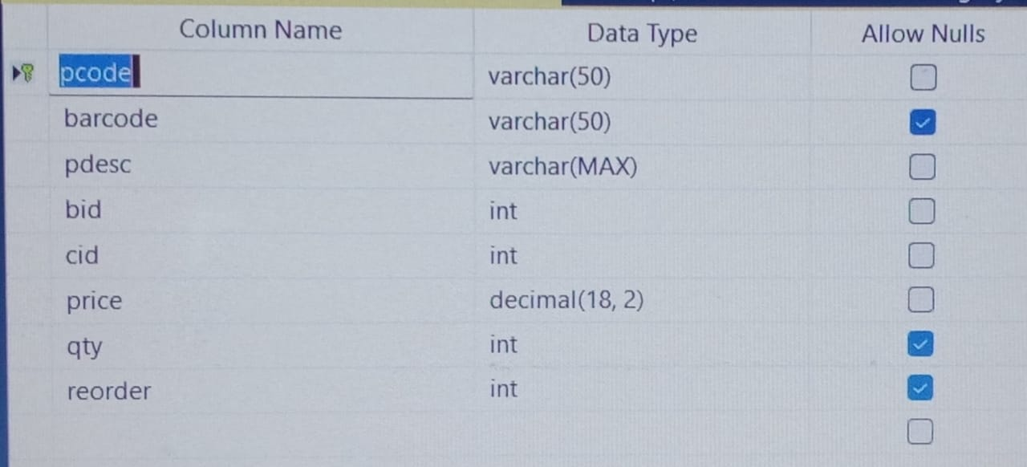

SCREENSHOT

1. **Progress Bar**

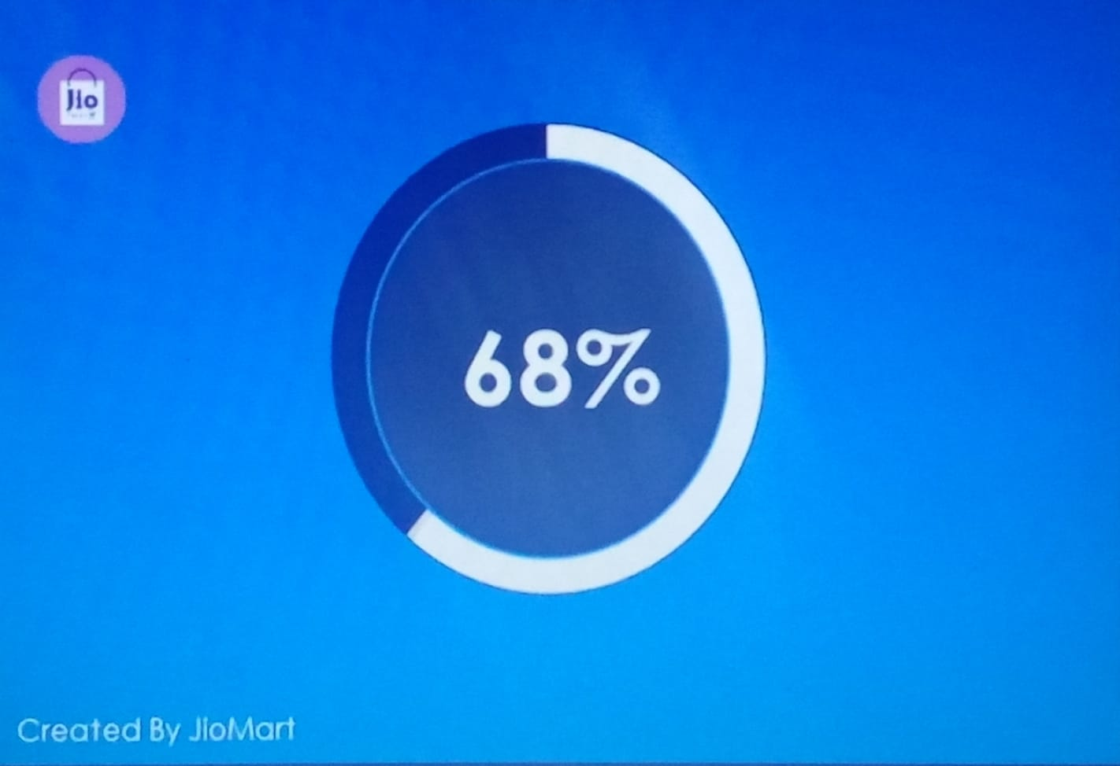

1. **Login**

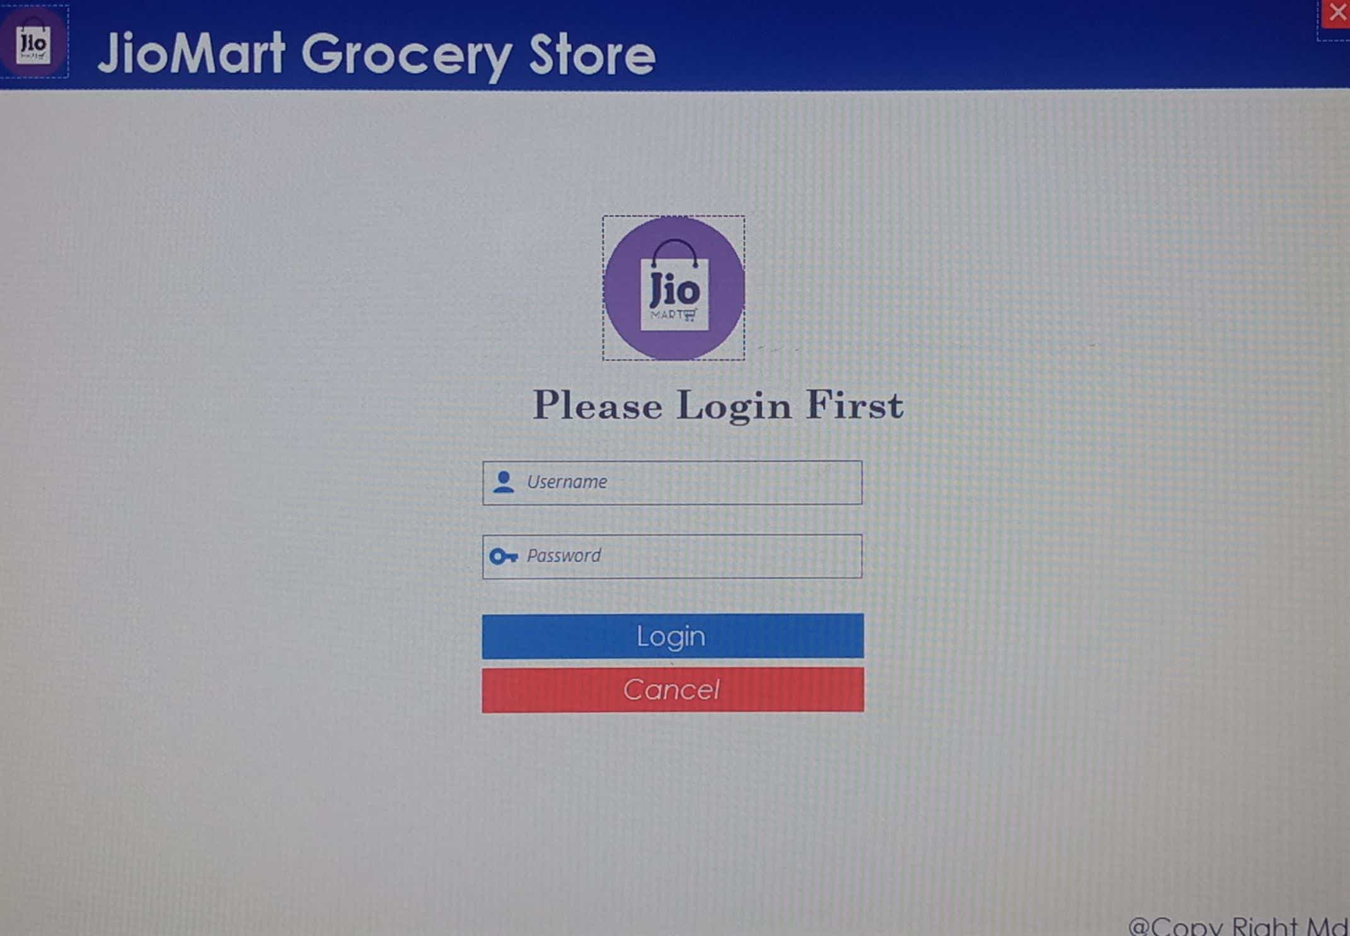

1. **Dashboard**

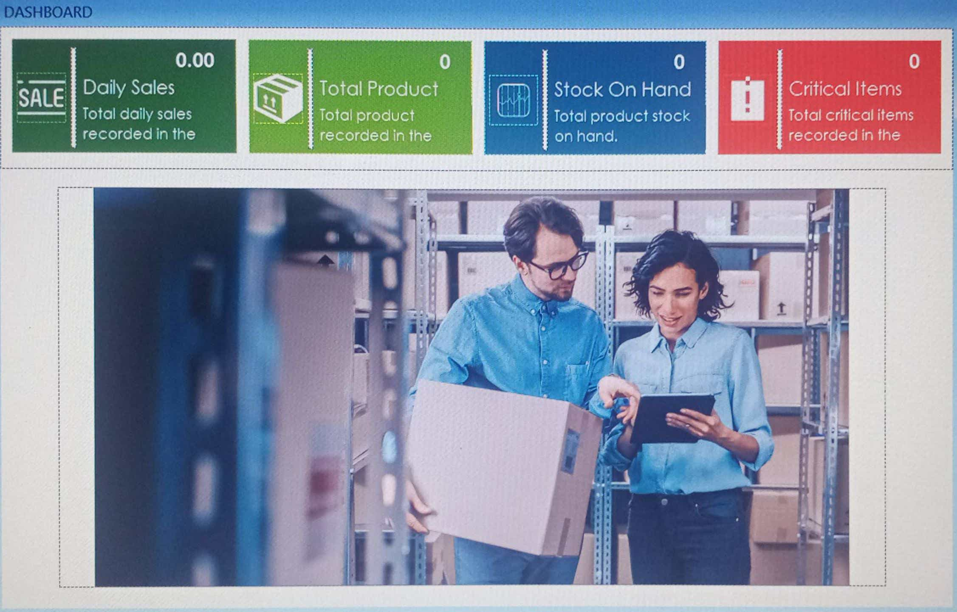

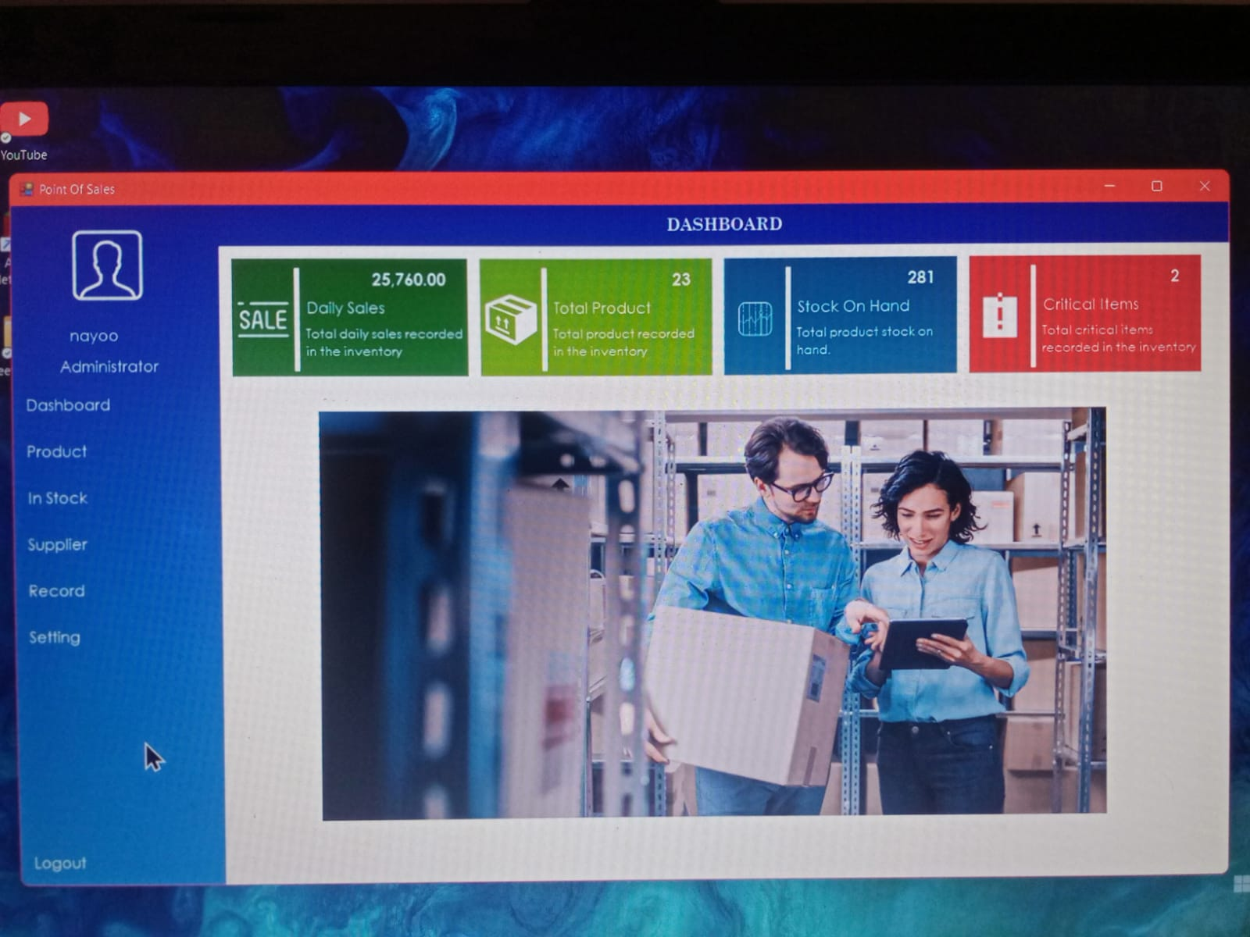

1. **MainForm**

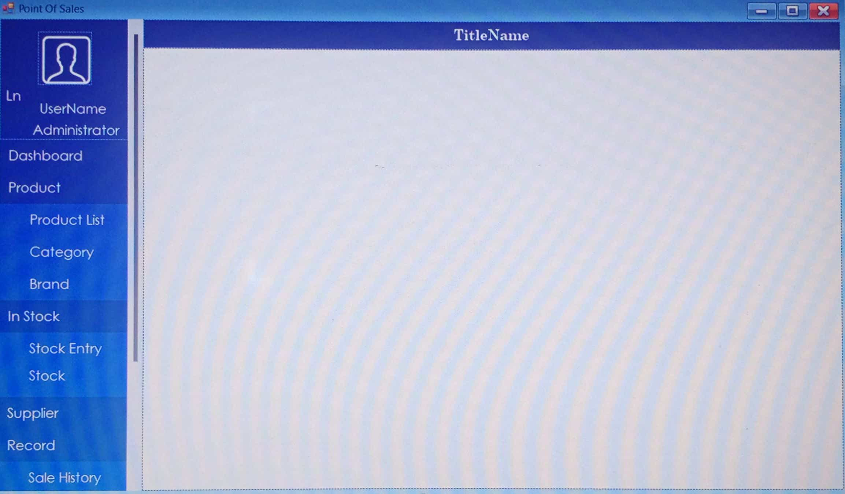



1. **Brand**

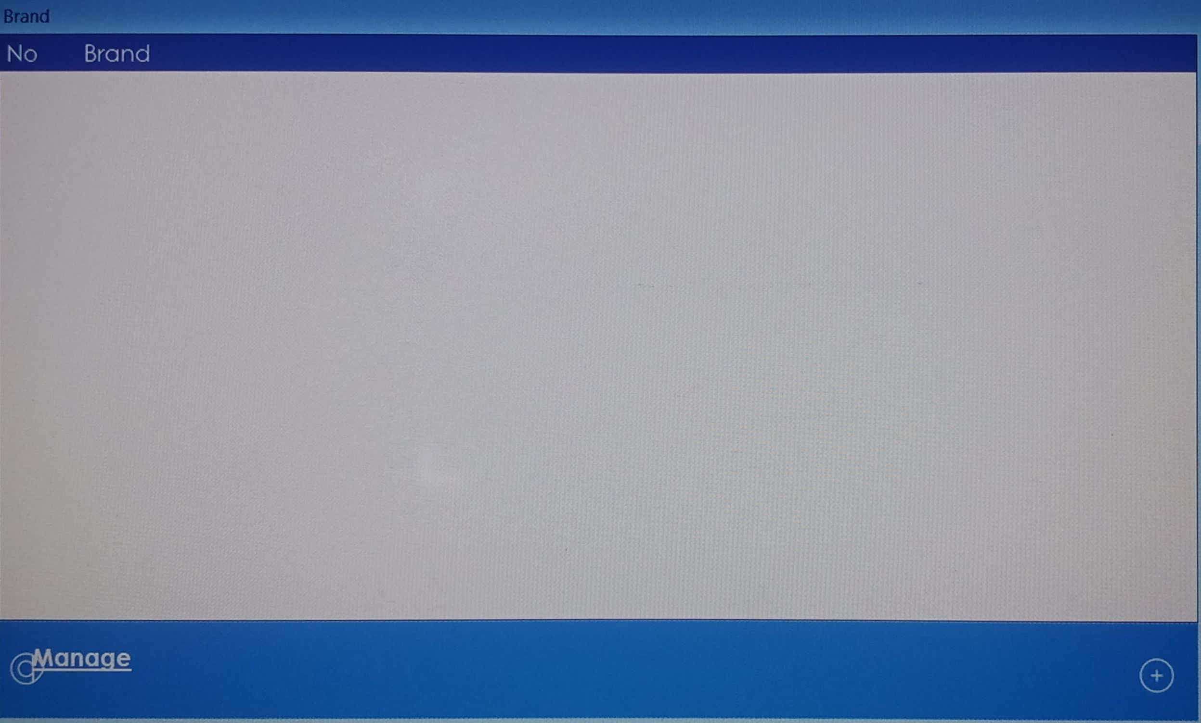

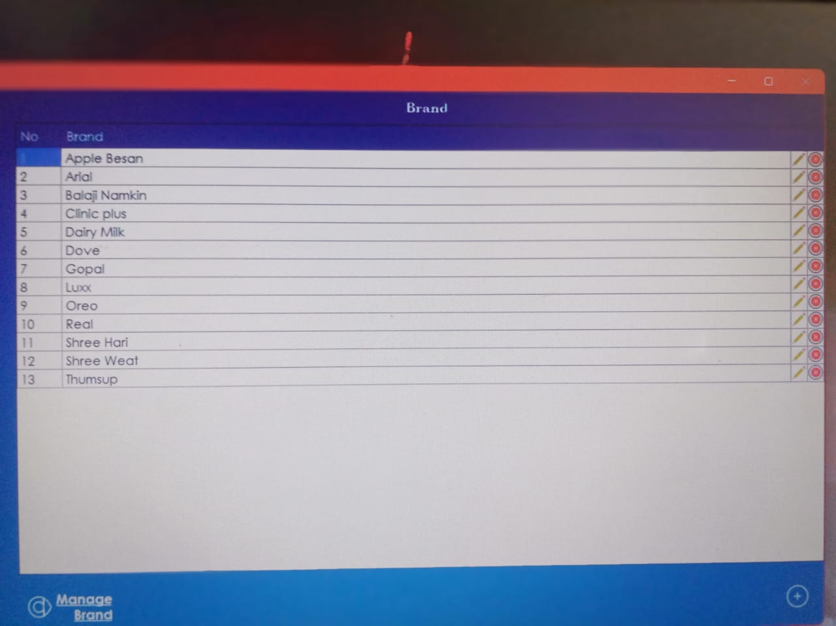

1. **Category**

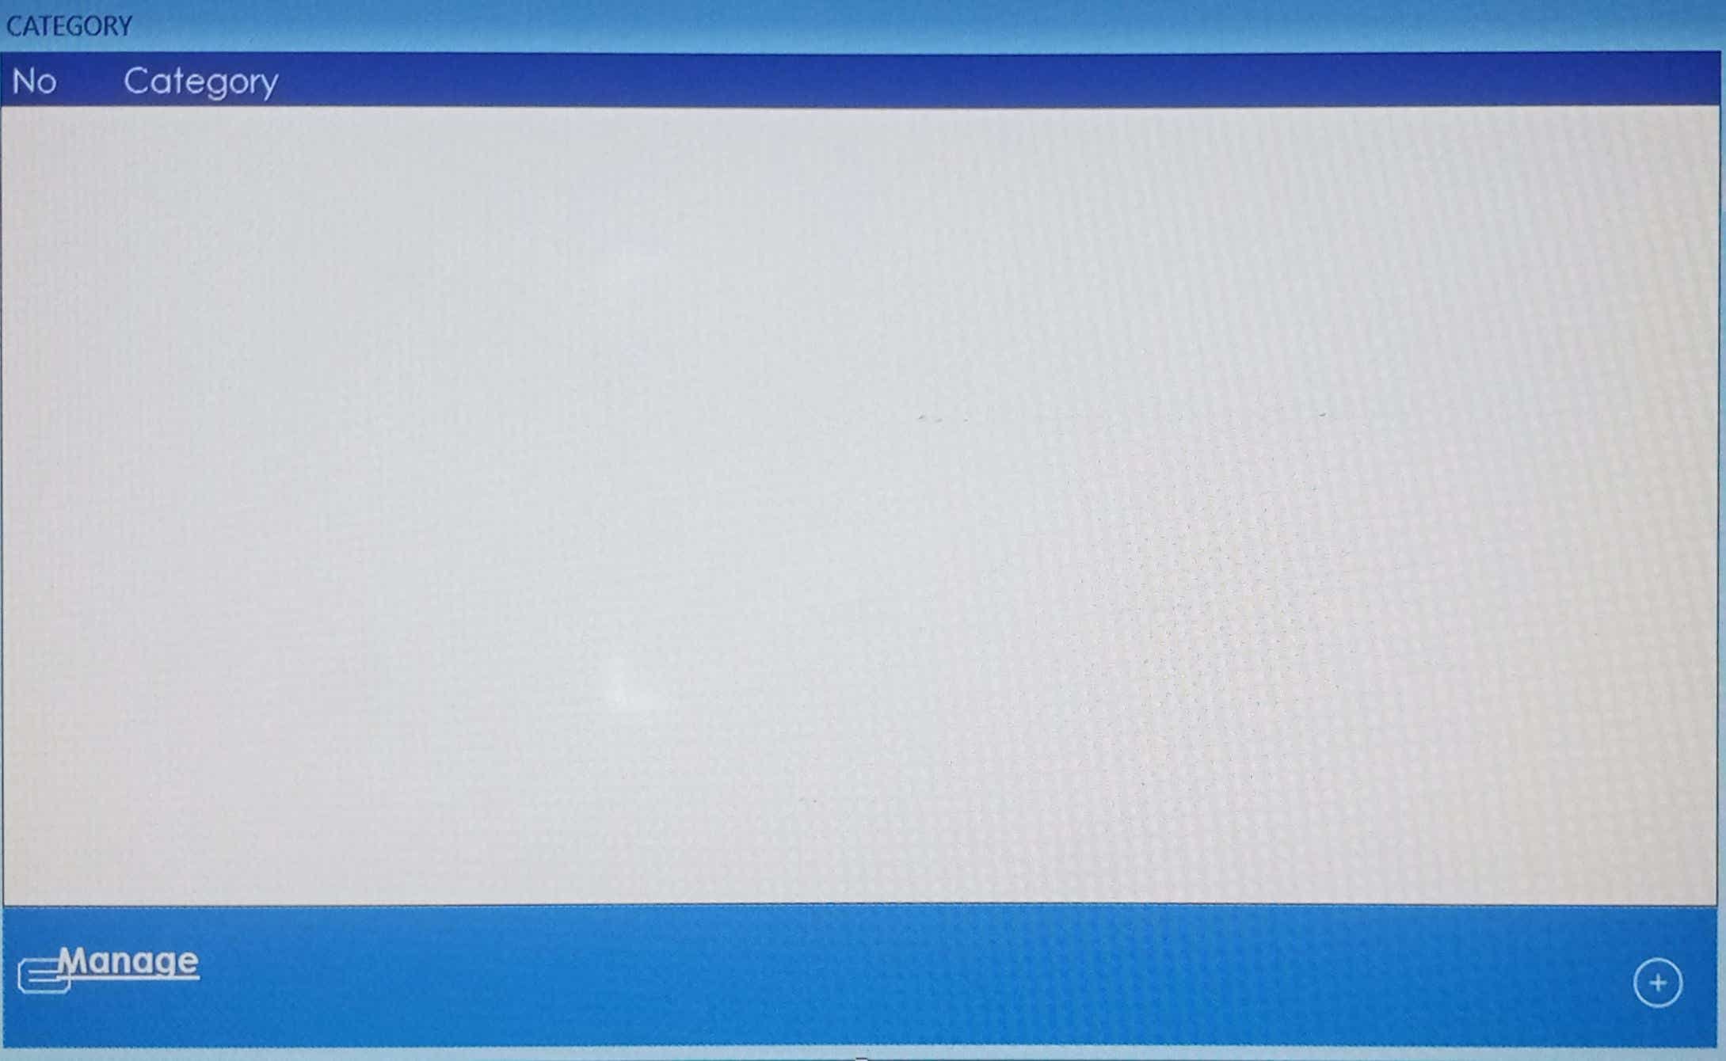

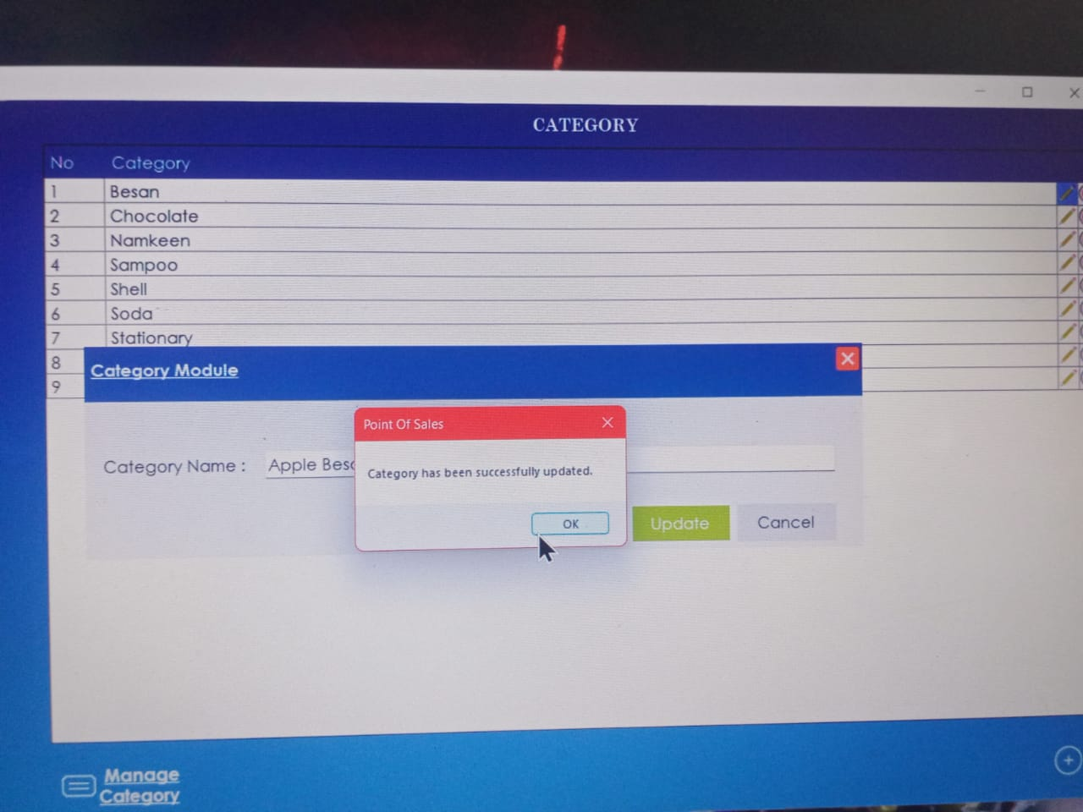

1. **Cashier**

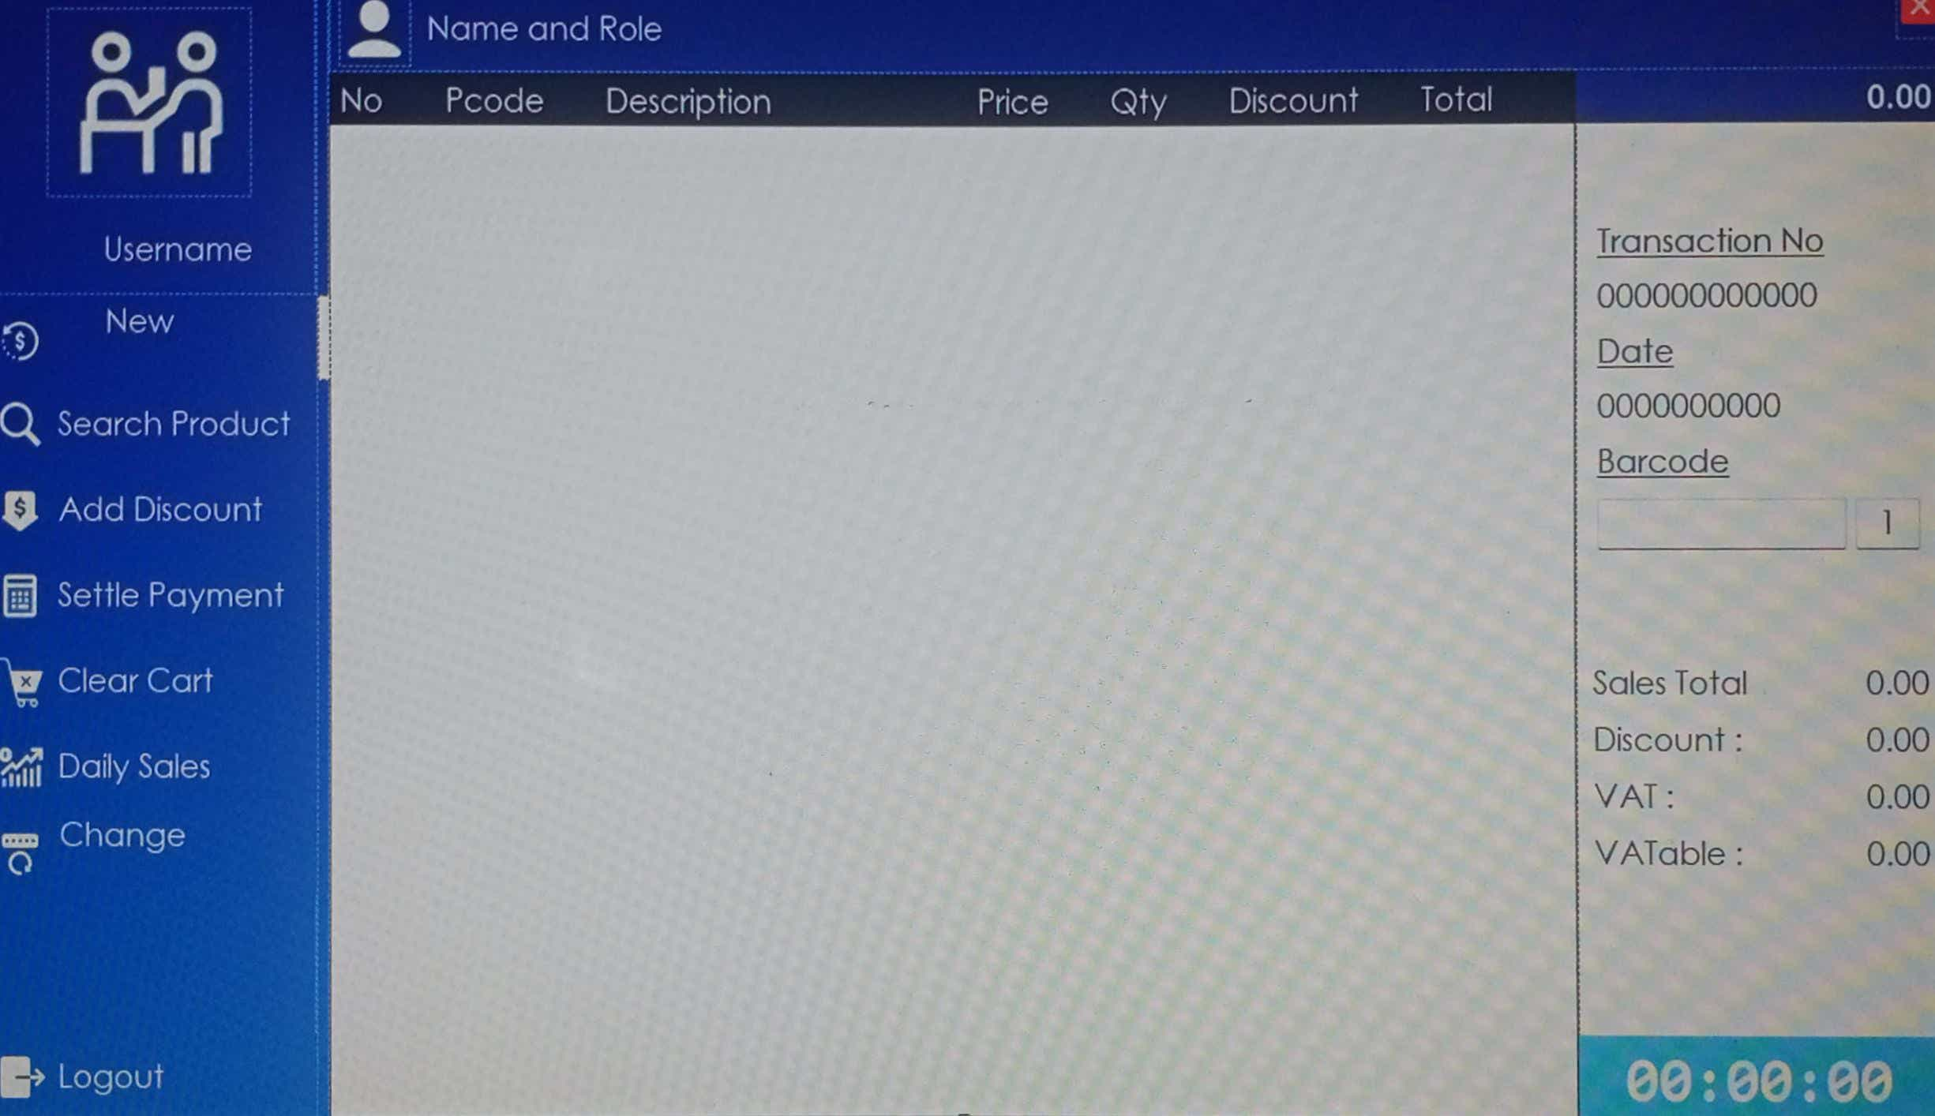

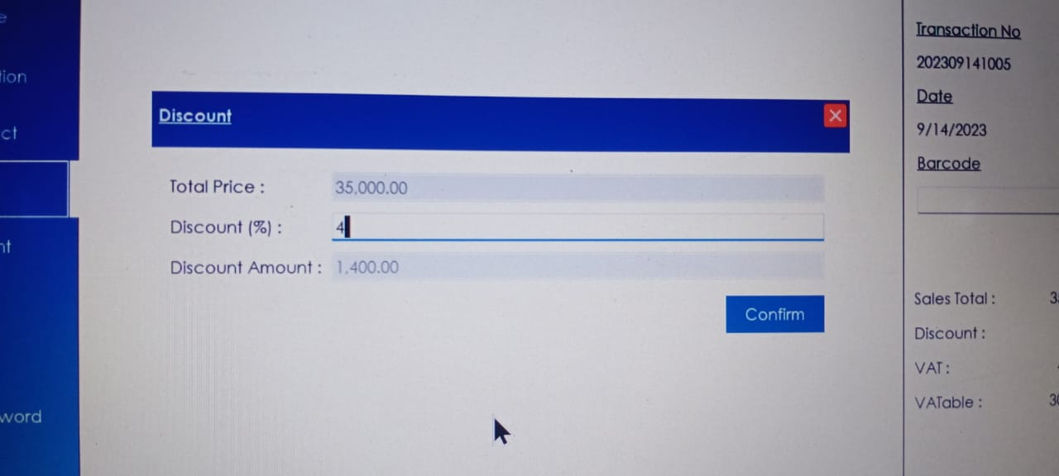

**Change password**

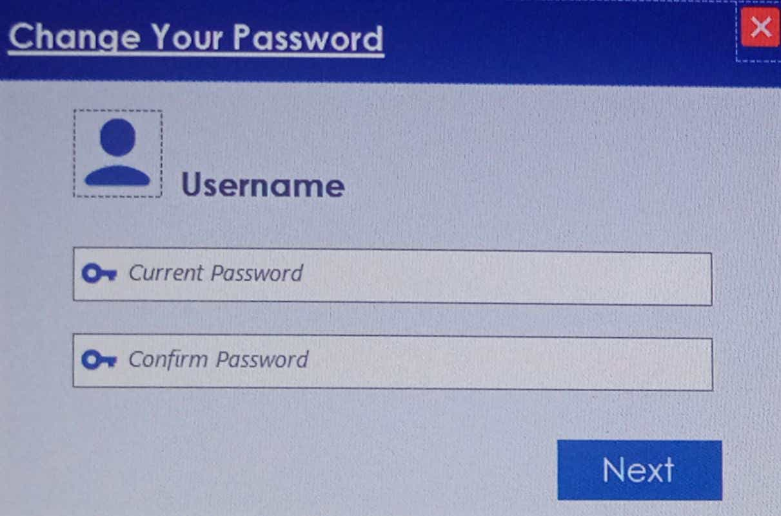

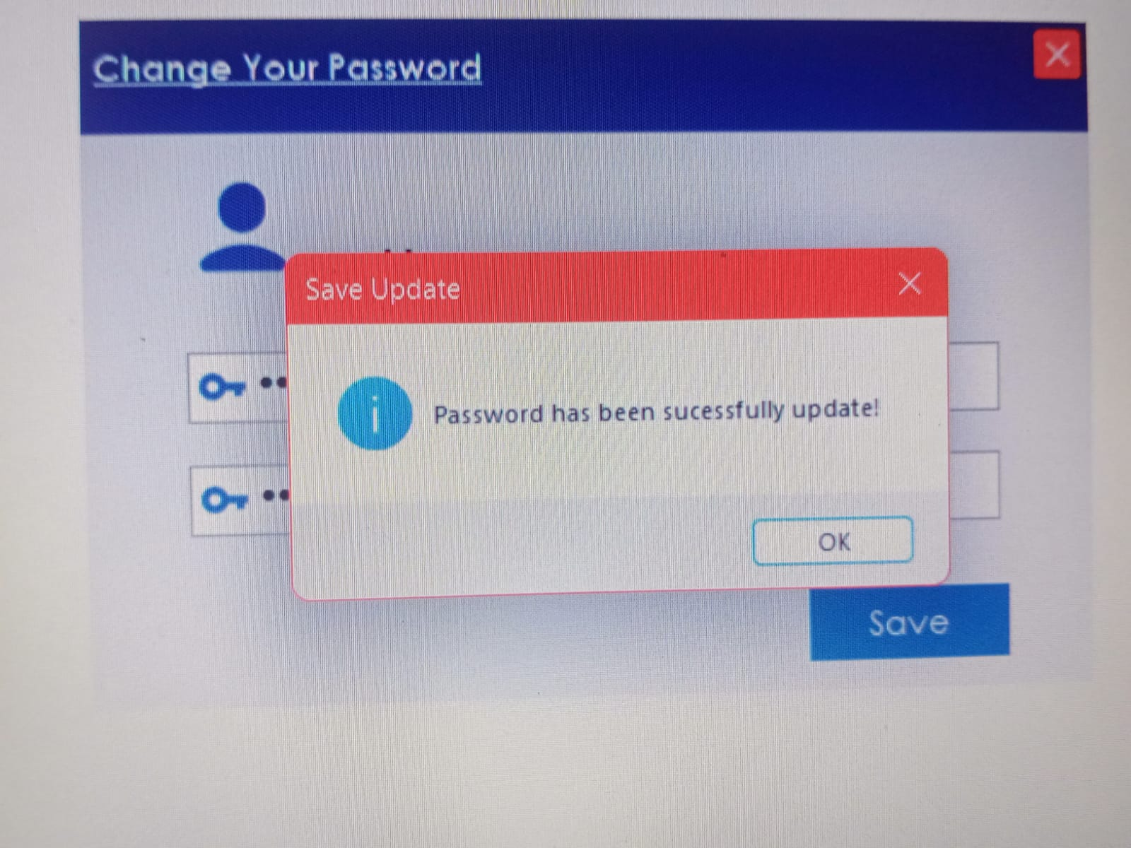

1. **Daily Sale**

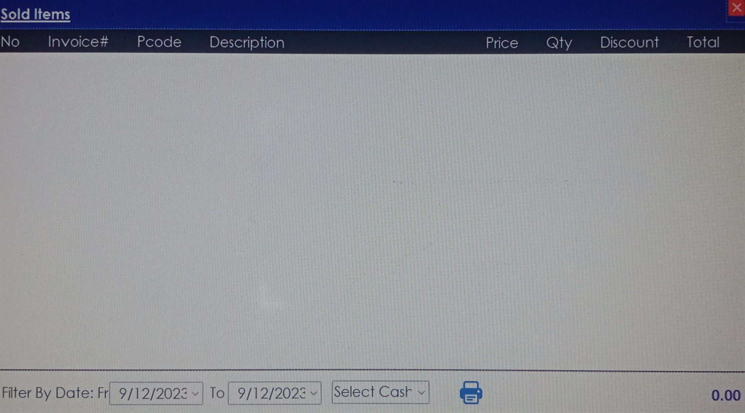

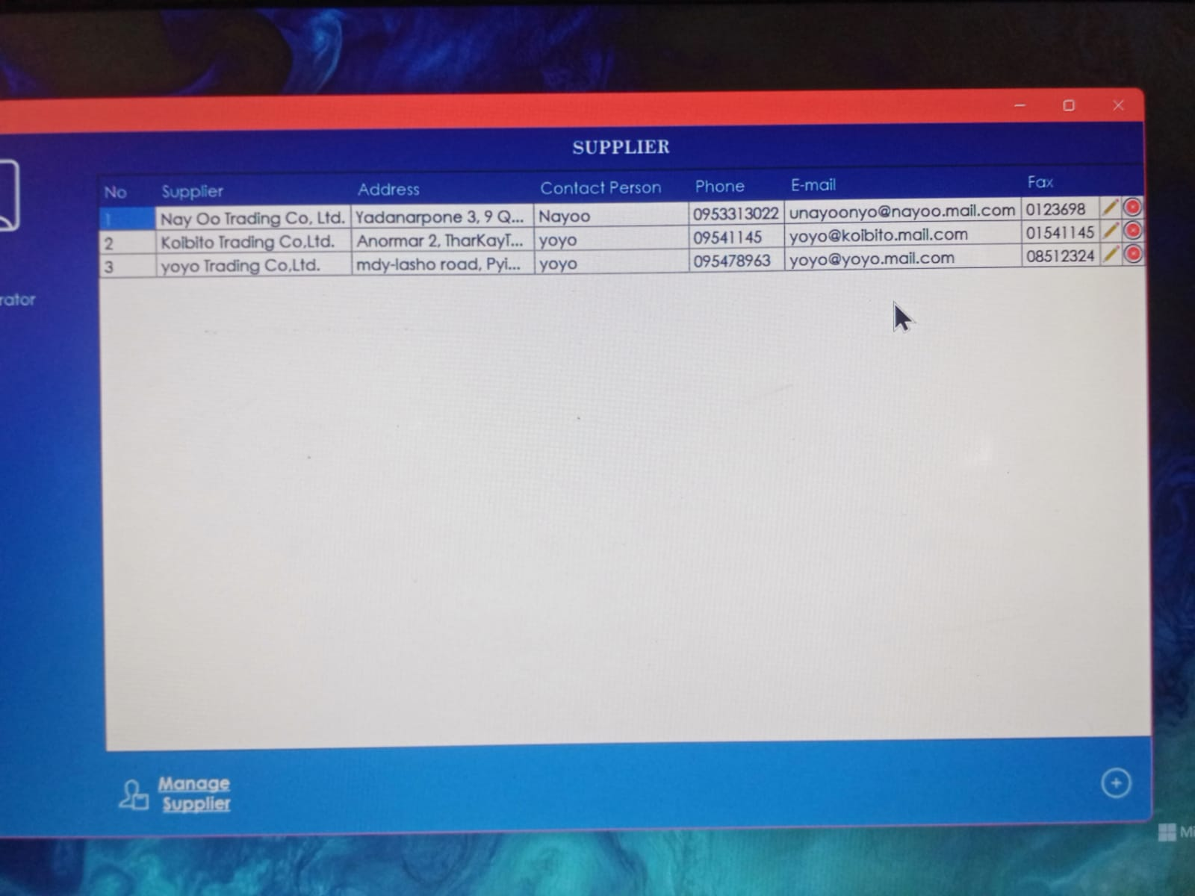

1. **Discount**

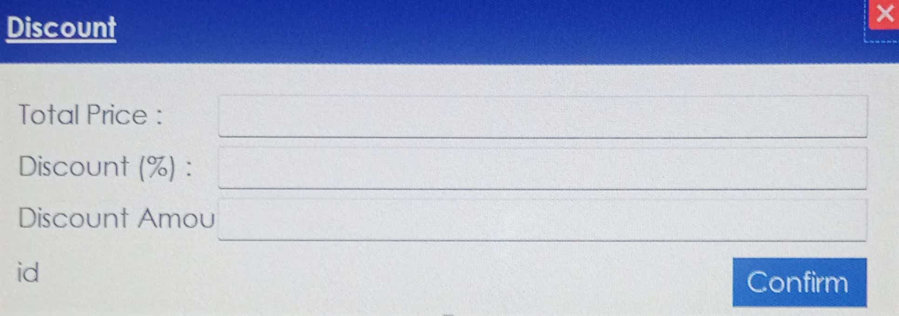

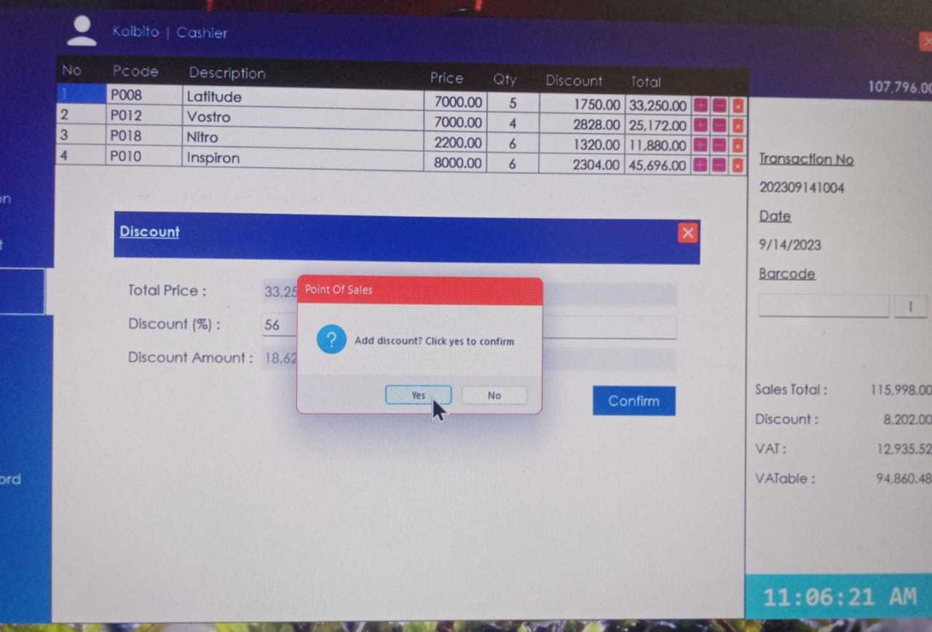

1. **Lookup Product**

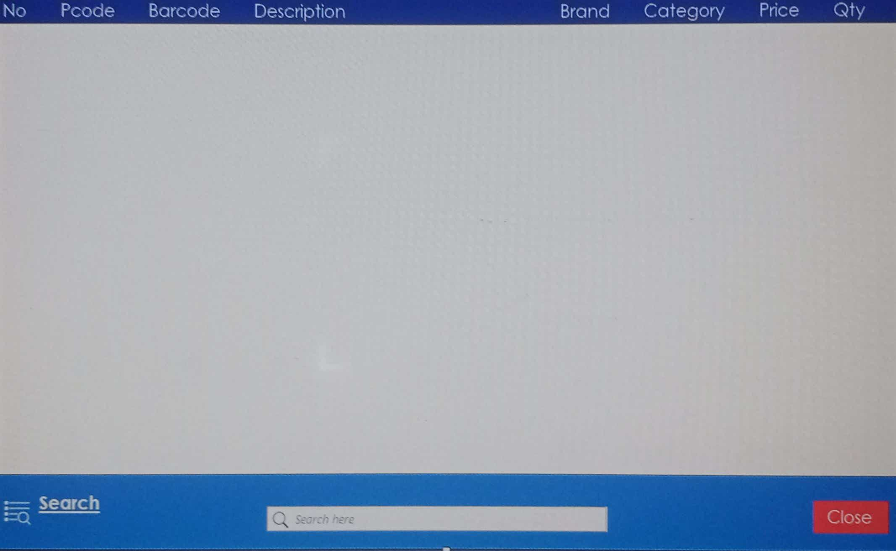

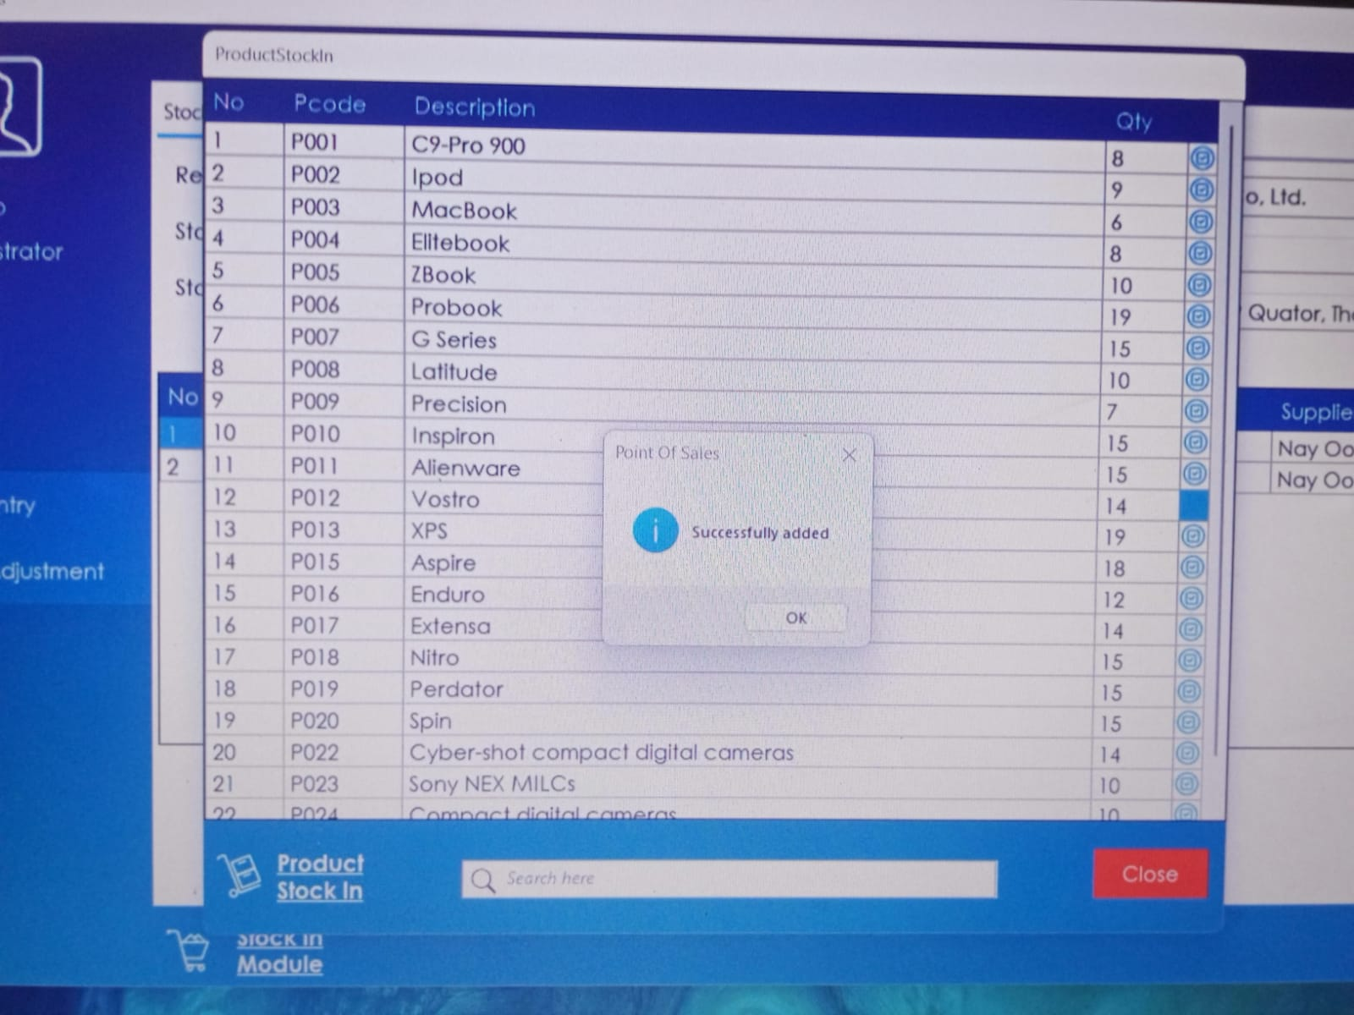

1. **Product**

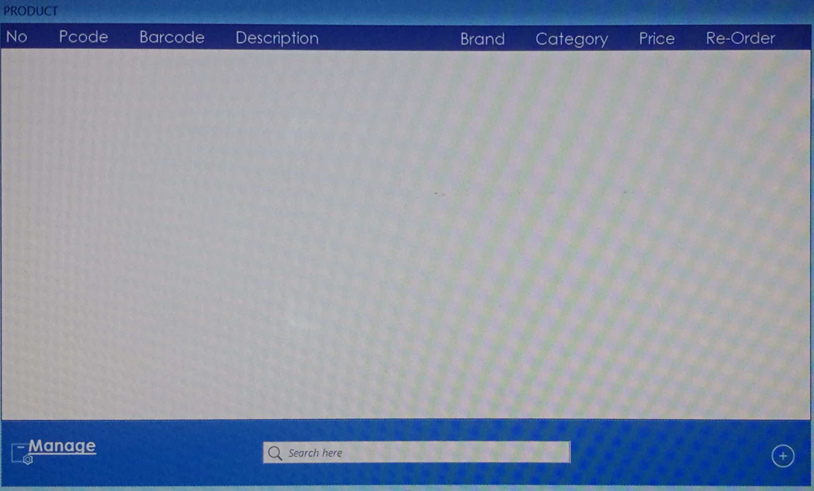

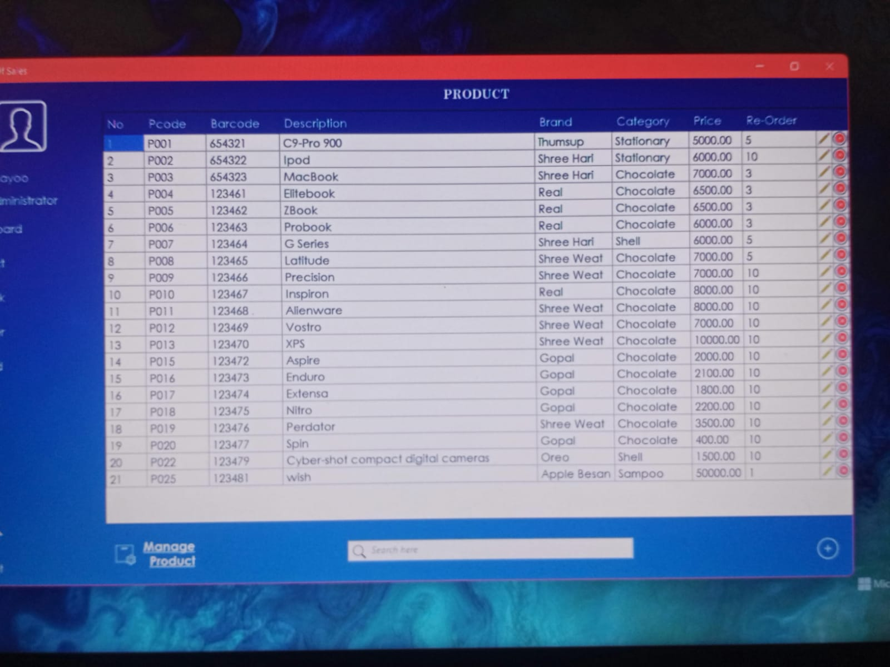

1. **Records**

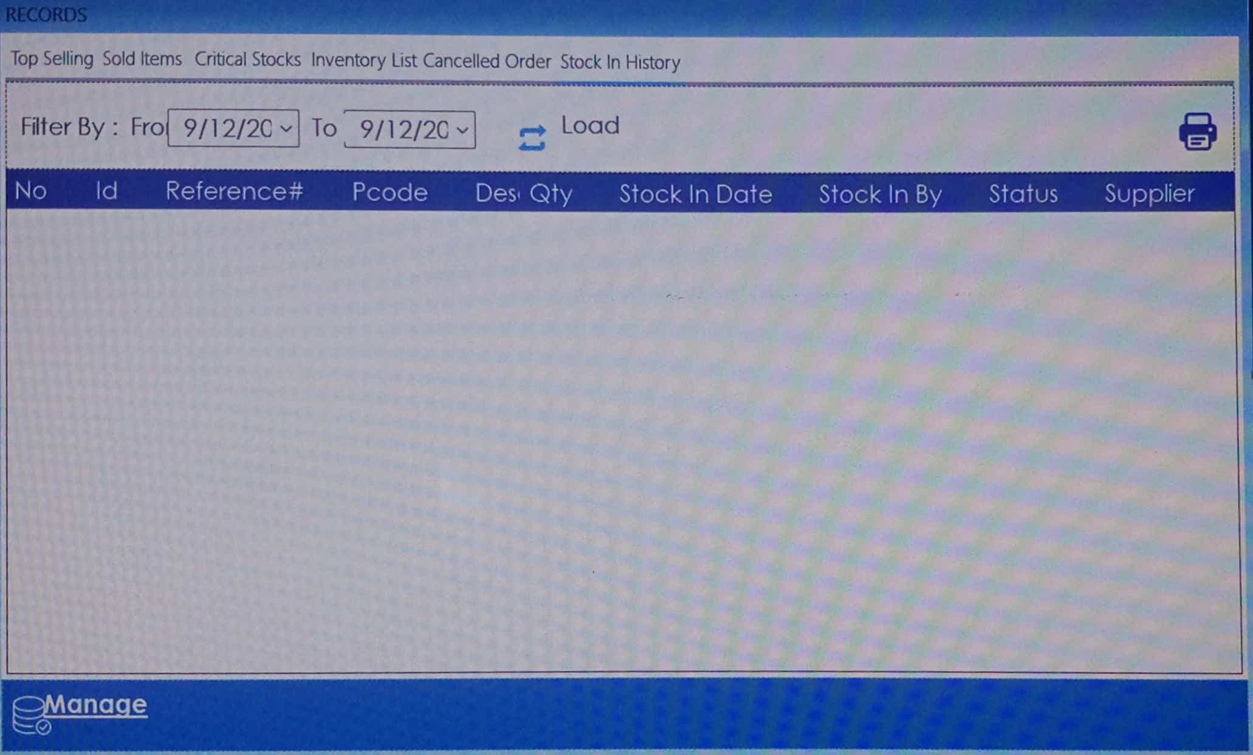

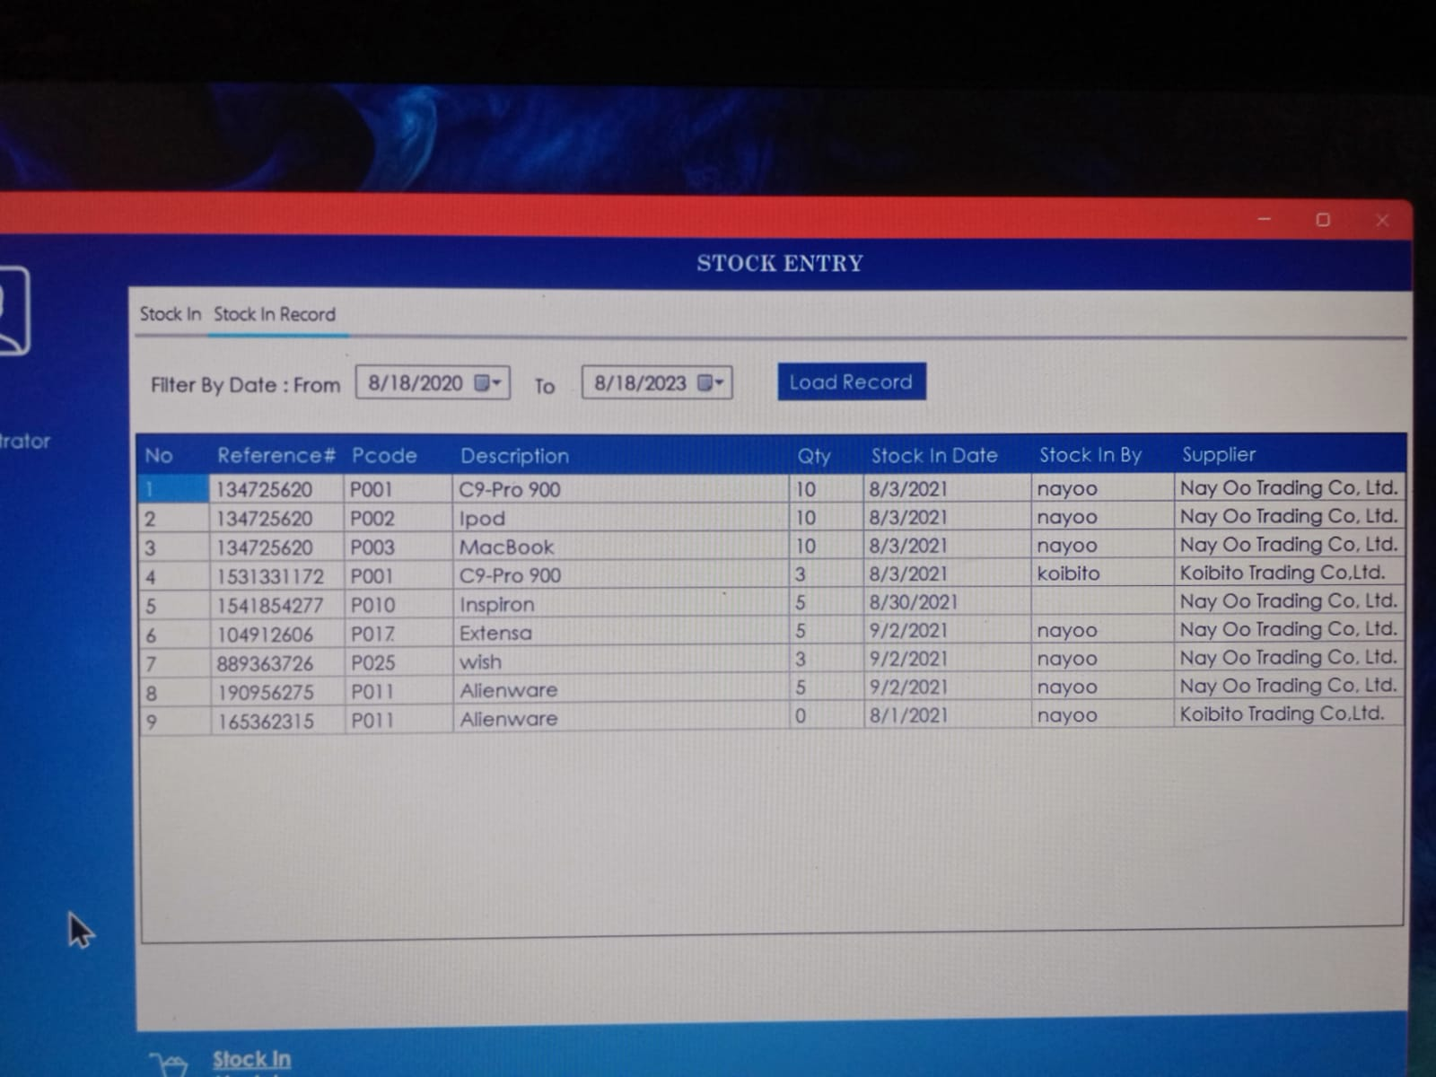

1. **Settle Payment**

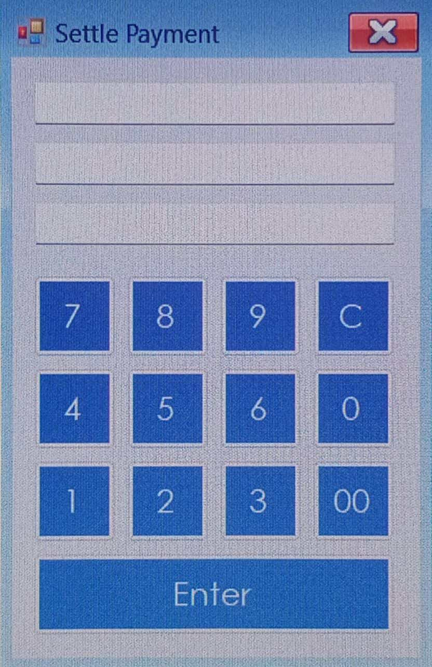

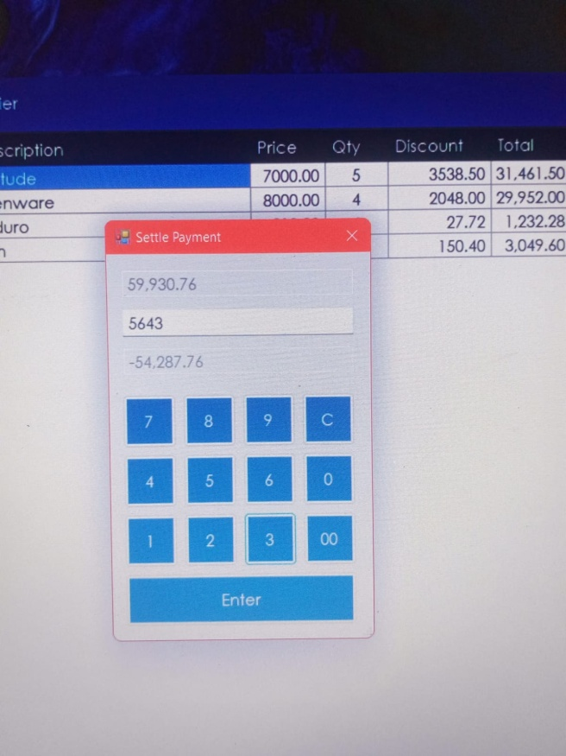

1. **Store**

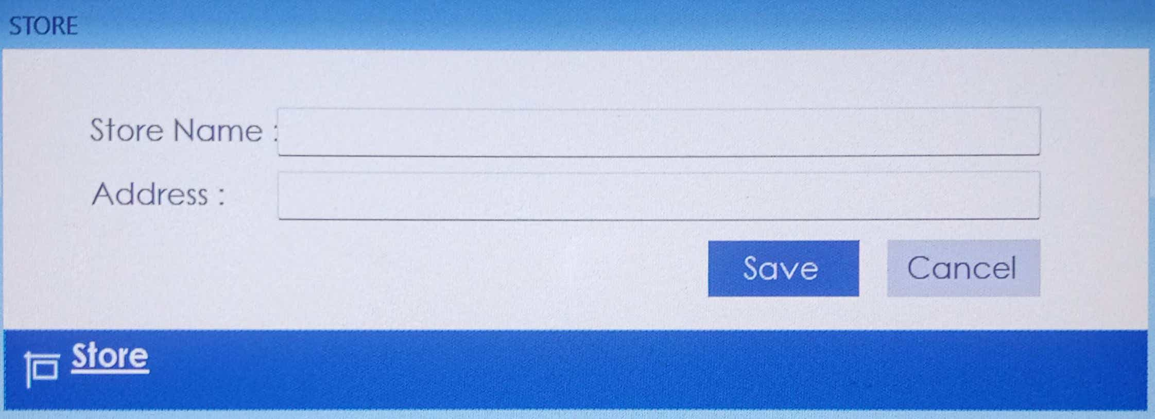

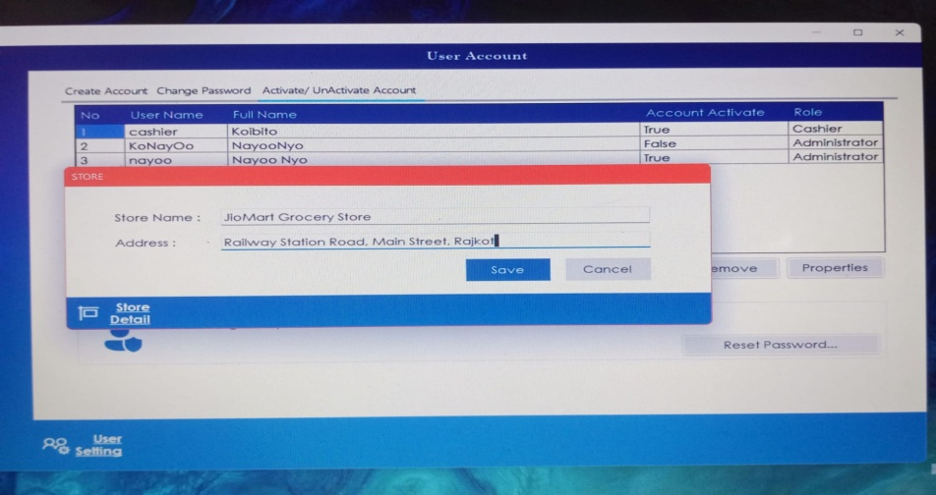

1. **Supplier**

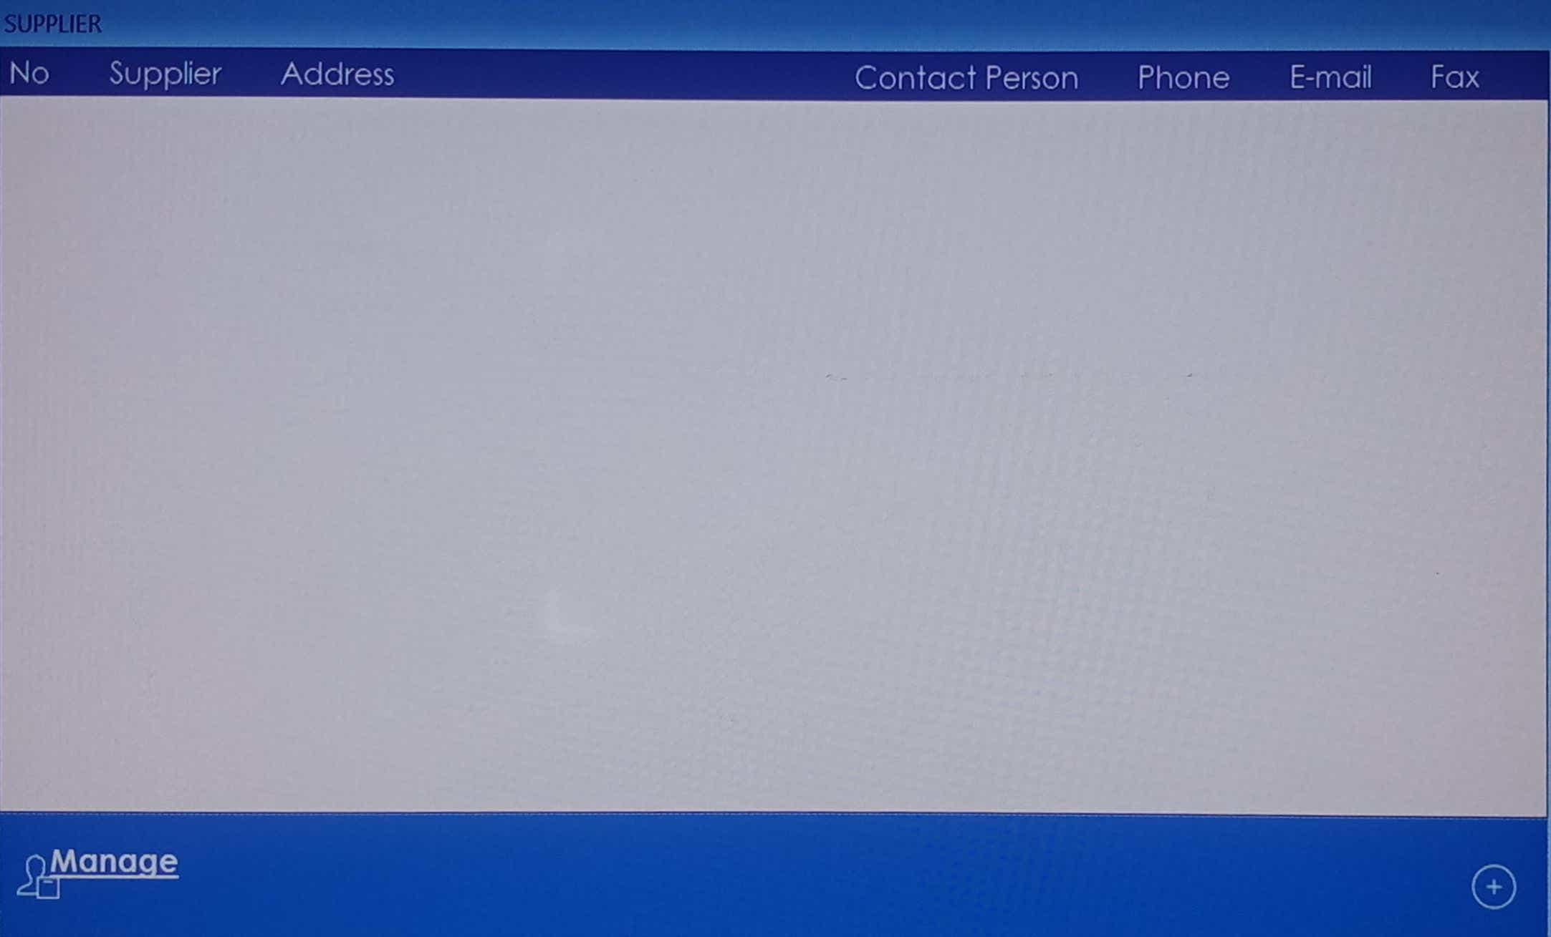

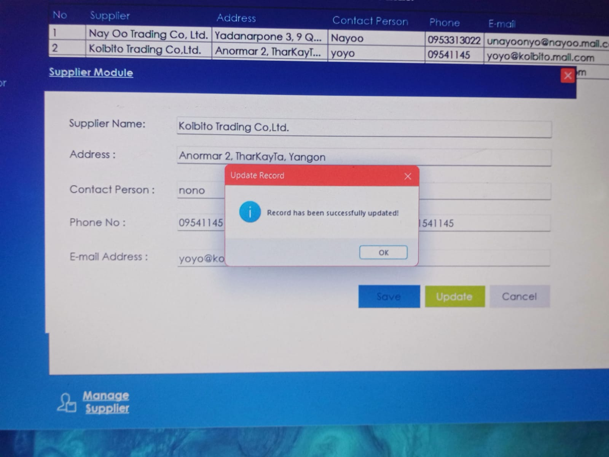

1. **User Account**

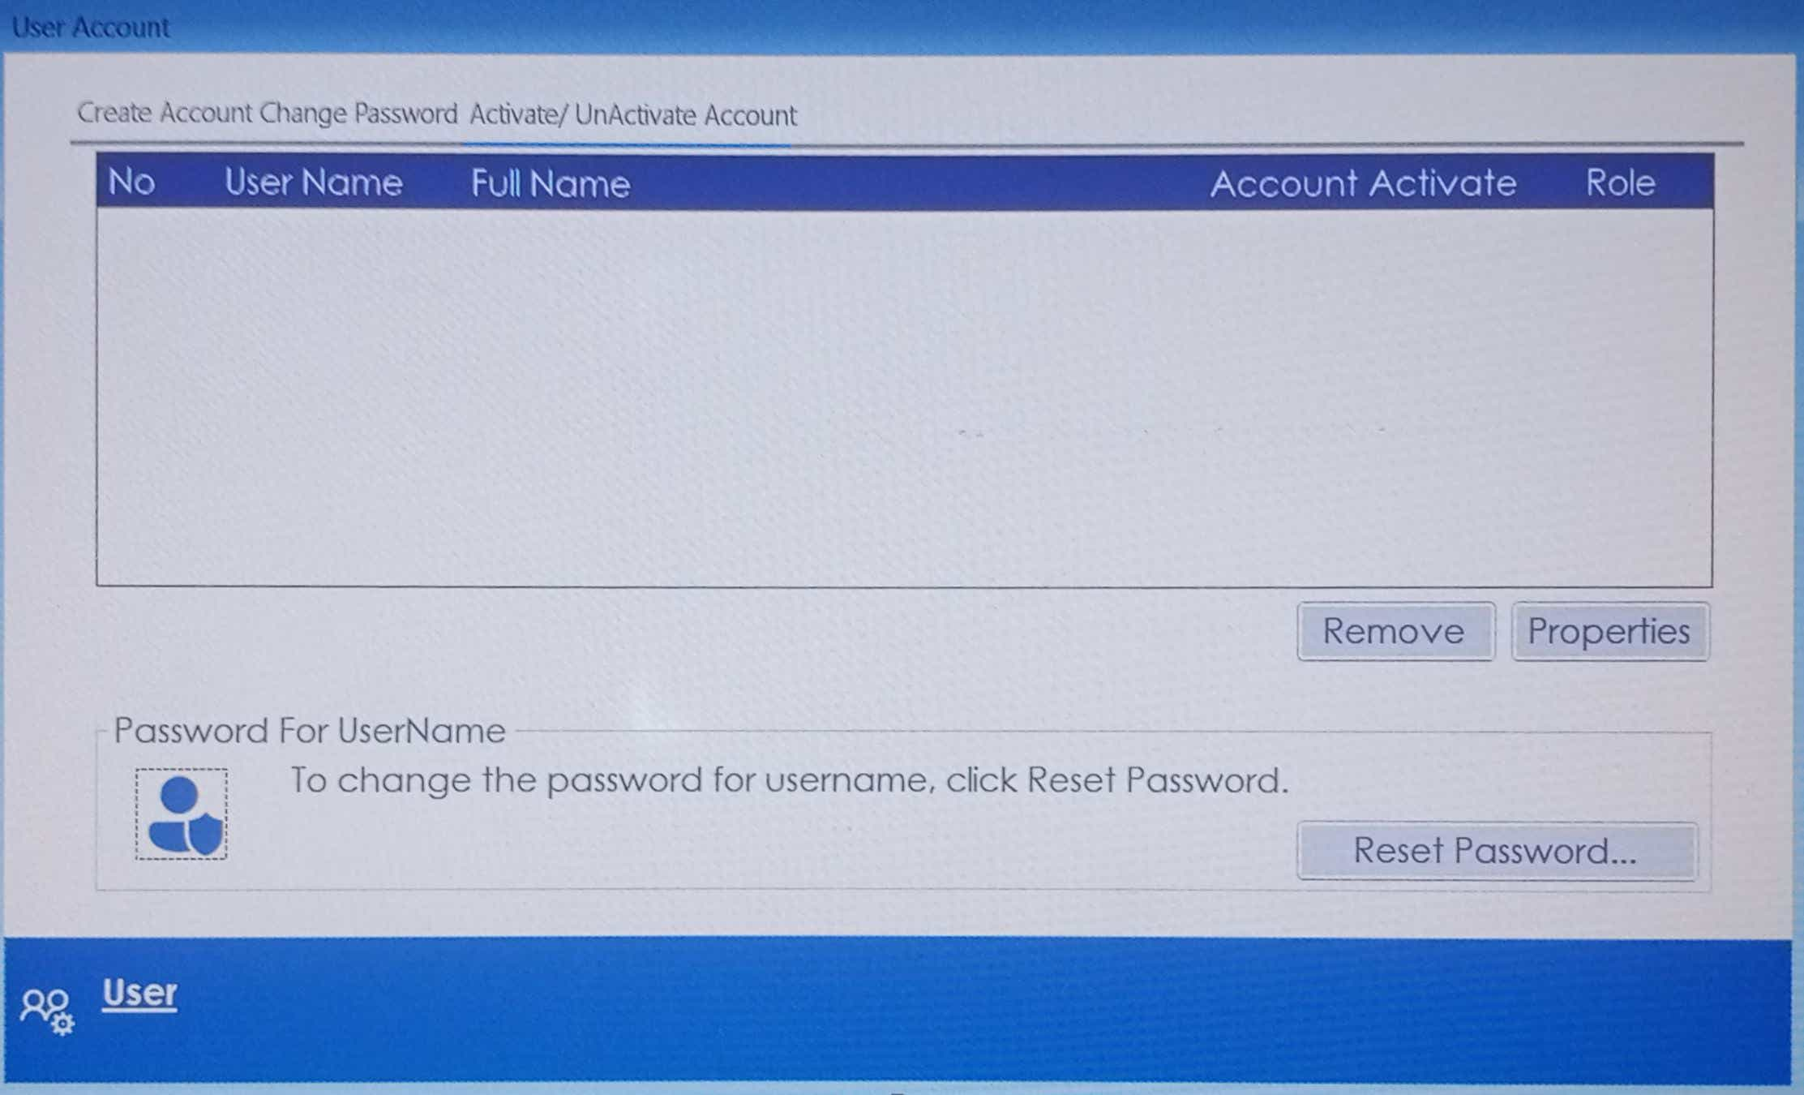

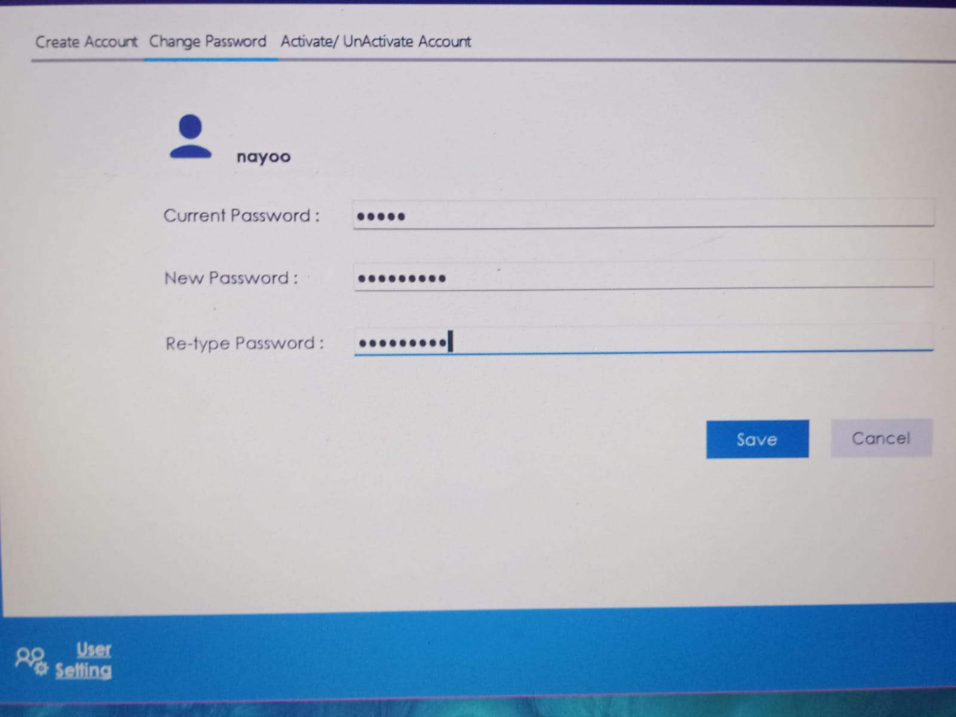

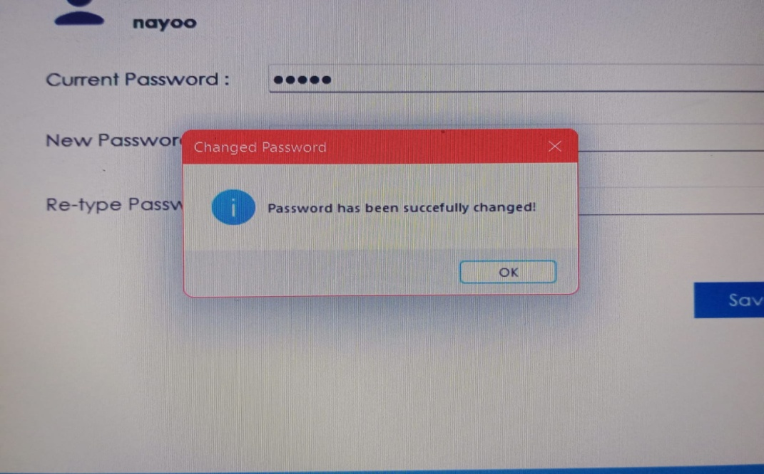

REFERENCE

* **The following sites are been accessed for this project related solution :-**
* www.google.com
* Wikipedia
* YouTube

* **Books we have used for reference are :-**
* Programming with C#.Net
* System Analysis and Design

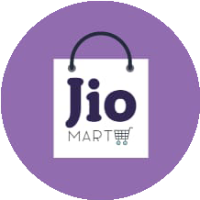

BIBLIOGRAPHY

* **The books we referred for making our project error free are :-**
* Programming with C#.Net
* System Analysis and Design

